

Model SX726
Conductivity/DO Meter

Operation Manual

Shanghai San-Xin Instrumentation Inc.

SX700 Series of Portable Meters

1. Model SX711 pH / mV Meter
2. Model SX712 ORP Meter
3. Model SX713 Conductivity / TDS / Salinity / Resistivity Meter
4. Model SX716 DO Meter
5. Model SX721 pH / ORP Meter
6. Model SX723 pH /mV / Conductivity Meter
7. Model SX725 pH / mV / DO Meter
8. Model SX726 Conductivity / DO Meter
9. Model SX731 pH / ORP / Conductivity Meter
10. Model SX736 pH / mV / Conductivity / DO Meter
11. Model SX751 pH / ORP / Conductivity / DO Meter

Content

1. Summary ----------------------------------------------------------------------------------------------
4
6
7
7
8
9
10
10
10
11
11
14
18
19
19
20
20
21
23
25
26
2. Technical Parameters -------------------------------------------------------------------------------
3. Meter Overview ------------------------------------------------------------------------------------
3.1. LCD Display -------------------------------------------------------------------------------------
3.2. Operation Keys ------------------------------------------------------------------------------------
3.3. The Storing, Displaying and Clearing of the Measuring Information ----------------------
4. Conductivity Measurement ------------------------------------------------------------------------
4.1. Preparation Work ---------------------------------------------------------------------------------
4.2. Meter Calibration ------------------------------------------------------------------------------
4.3. Sample Test --------------------------------------------------------------------------------------
4.4. Important Statement ---------------------------------------------------------------------------
4.5. Parameter Setting -------------------------------------------------------------------------------
4.6. Considerations -----------------------------------------------------------------------------------
5. DO Measurement -----------------------------------------------------------------------------------
5.1. Preparation Work --------------------------------------------------------------------------------
5.2. Meter Calibration --------------------------------------------------------------------------------
5.3. Water Sample Test -------------------------------------------------------------------------------
5.4. Considerations -----------------------------------------------------------------------------------
5.5. Parameter Setting --------------------------------------------------------------------------------
5.6. Change the Membrane Cap ---------------------------------------------------------------------
5.7. Zero Oxygen Calibration ----------------------------------------------------------------------
5.8. Salinity Calibration ------------------------------------------------------------------------------
27
27
27
28
5.9. Barometric Pressure Setting ------------------------------------------------------------------
6. Meter’s Complete Kit --------------------------------------------------------------------------------
7. Warranty ----------------------------------------------------------------------------------------------
TableⅠ Meter Parameter Setting Table
TableⅡ Meter Restore to Default Setting Table
Table Ⅲ Code Icon and Abbreviation Table
Table Ⅳ Content of Saturated Oxygen in Water at Different Temperature
Table V Content of Saturated Oxygen at Different Barometric Pressure
TableⅥ Content of Oxygen at Different Altitude

1. Summary:

Thanks for buying and using the model SX726 Conductivity/DO Meter (the following called “meter” in short).
Before using this meter, please read the operation manual carefully in order to help use and maintain it correctly. On the basis of improving instrument of performance constantly, we reserve the right of changing the content of this manual and accessories in case of not notifying in advance.
This meter is a perfect combination with the most advanced electronic technology, sensor technology and software design. The meter can measure the parameters of conductivity, TDS, salinity, resistivity, DO and temperature for high accuracy water solution. It is the best portable water analysis meter with the highest performance and the lowest cost. It is suitable for the trade such as the mining industry, power plant, water treatment projects and environmental protection, etc., especially has more extensive application in the field and spot test.
Built-in microprocessor chip, beautiful appearance, multi-functional and easy to use, this meter has the following prominent features:
1.1. Double parameters meter, equipped with conductivity electrode, DO electrode, calibration solution and special carrying case, easy to use.
1.2. Built-in microprocessor chip. Its features up to functions of automatic calibration, automatic temperature compensation, data storage, function stting, auto power off and low voltage indication etc.
1.3. Adopts digital filter and step slipping technology to intelligently improve meter’s response speed and result accuracy. “ ” will appear when reading to be stable.
1.4. Adopts advanced automatic frequency convertible and voltage regulation technology to enlarge the measuring range 10 times for conductivity electrode which constant K=1. It can meet measuring accuracy requirement for range within 0 to 200mS/cm by using only one-point calibration. It is the particular one–point calibration function for this meter.

1.5. It automatically recognizes 8 kinds of conductivity standard solution. User can choose anyone from two series of standard solutions: Europe & USA series and China series.
1.6. Automatically select conductivity measuring range, the meter will do non-linearity temperature compensation test for purified and high purified water less than 10 uS/cm, which greatly improve the measuring accuracy. It is especially suitable for use in fields of electric power, microelectronics and medicine.
1.7. Equips new type of DO electrode with temperature and salinity sensor which has function of automatic temperature compensation and automatic salinity compensation as well as manual barometric pressure compensation inside meter, easy to use, accurate to measure.
1.8. Polarogram type DO electrode has special electrode calibration cap. Only needs 3 to 5 minutes for electrode polarization. Electrode adopts combination diaphragm cap which very convenient to use. Each DO electrode equips with three spare diaphragms caps.
1.9. Meter’s circuit board adopts SMT film-covering technology to improve meter’s production reliability.
1.10. Meter has the blue backlight LCD display.
1.11. Dustproof and waterproof meter meets IP57 rating.
2. Technical Parameters:

2.1. Conductivity:
Measuring range | Conductivity:  (0.00 to 19.99) μS/cm (20.0 to 199.9) μS/cm  (200 to 1999) μS/cm (2.00 to 19.99) mS/cm  (20.0 to 199.9) mS/cm  TDS: (0 to 100) g/L  Salinity: (0 to 100) ppt  Resistivity:(0 to 100) MΩ ● cm
Resolution | 0.01/0.1/1μS/cm 0.01/0.1 mS/cm
Accuracy | Meter: ±1.0% FS, Overall: ±1.5% FS
Temp. compensation range | (0 ~ 50) ℃(automatic)
Electrode constant | 0.1 / 1 / 10 cm⁻¹
Benchmark temperature | 25℃, 20℃and 18℃
2.2. Dissolved Oxygen:
Measuring range | (0 to 40.00) mg/L (ppm) (0 to 200.0) %
Resolution | 0.1/0.01 mg/L (ppm) 1/0.1 %
Accuracy | Meter: ±0.10 mg/L, Overall: ±0.40 mg/L
Response time | ≤30 s (25℃, 90% response)
Residual current | ≤0.1 mg/L
Temp. compensation range | (0 to 45) ℃ (automatic)
Salinity compensation range | (0 to 45) ppt (automatic)
Barometric pressure range | (66 to 200) kPa (manual)
Automatic calibration | Air saturated by water; water saturated by air
Electrode type | Polarogram type
2.3. Other Technical Parameters:
Data storage | 200 groups
Storage content | Series number, measuring value measuring unit and temperature value.
Power | Two AA batteries (1.5V x2)
Size and weight | Meter: (65×120×31) mm/180g; carrying case:  (360×270×76) mm/1.6Kg
Quality and safety certification | ISO9001:2000, CE and CMC
2.4. Working Condition:
Environment temperature | 5 to 35 ℃ (0.01 grade)
Environmental humidity | ≤85%
IP rating | IP57 Dustproof and waterproof

3. Meter Overview:

3.1. LCD Display:
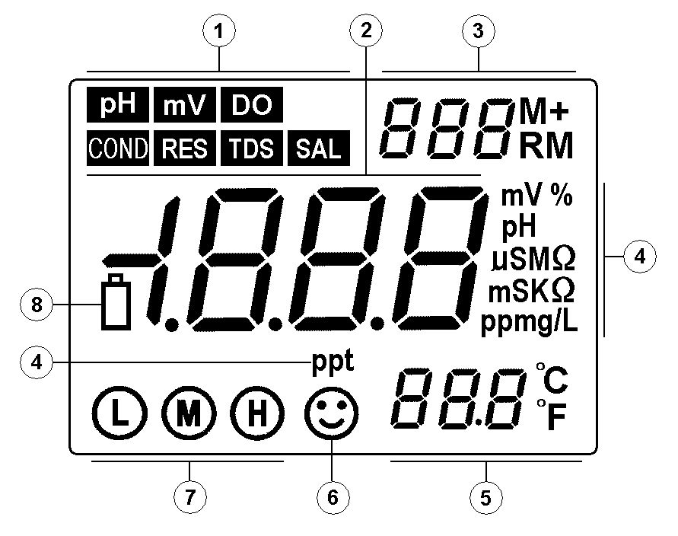

① —— Parameters mode icon
② —— Measuring value
③ —— Serial number and icon as measuring value to be stored and displayed, and indication icons for special states.
M+ — measuring value to be stored icon;
RM —measuring value to be displayed icon;
④ —— Measuring unit
⑤ —— Temperature measuring value and unit
⑥ —— Measuring value to be stable icon
⑦ —— Electrode calibration indicating icon
⑧ —— Indicating icon of low voltage, appearing when the voltage is less than 2.6V, calling attention to change the batteries.
3.2. Operation Keys:
The meter has 5 operation keys in all.
3.2.1. — Switch on / off key
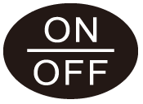
3.2.2. — Calibration key

(a) When in the measurement state, press this key to enter into calibration mode.
(b) When in the parameter setting state, press this key to change the number or the ON/OFF state.
3.2.3. — Function key
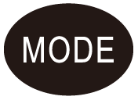
Press this key to enter into parameters setting, the meter will display cyclically P1,P2,P3…
3.2.4. — Backlight and entrance key

(a) When in the measuring state, short-time press (<1.5s) to turn on or off the backlight display;
(b) When in the calibration state or in the parameter setting state, press this key to confirm, and then the meter will enter into measuring state;
(c) When in mode, press it without releasing to display modes cyclically:


(total dissolved solid)→ (salinity) → (resistivity)→ (conductivity), and then release the key after choosing.


(d) When in mode, long-time press the key to cyclically change unit symbol: mg/L→ppm→%, and then release the key after choosing.

3.2.5. — The combination key of storage and display
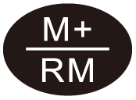
(a) When in the measurement state, short-time press (< 1.5s) to store the measuring data, long-time press (＞2s) to display the saved measuring data.
(b) When in the parameter setting state, press to change the number or ON/OFF state.
3.3. The Storing, Displaying and Clearing of the Measuring Information:
3.3.1. Store the measuring information:
In the measuring mode, when the measuring data is stable and appears the “ ”, short-time press key (＜1.5s), LCD will display “ M+ ” icon and stored serial number, and meanwhile store all the measuring information. Meter can separately store 100 groups of measuring information in the mode of conductivity and dissolved oxygen, thus it can totally store 200 groups.
3.3.2. Display measuring information:
(a) Under the measuring mode, long-time press the key, meter will display the last stored information, and the stored number and “ RM ” icon will appear in the lower right corner of the LCD, and the complete measuring information. Again press
or key, meter will in turn display all the measuring information, press or
key without releasing can make a quick query;
(b) In the displaying mode (there are “ RM ” and storage serial number in the upper right corner of the LCD), press key to return to the measuring mode.
3.3.3. Clearing the stored measuring information:
In the displaying mode, press the key for 5 seconds, LCD will appear “ ” for 2 seconds. It means the storage has been cleared, and the meter returns to measuring mode.
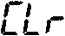

4. Conductivity Measurement:

4.1. Preparation Work:
4.1.1. Press key to turn on the meter,plug the 2301-S conductivity electrode to the meter, and the meter will automatically enter into conductivity measuring mode.
4.1.2. Press key to display (Total Dissolved Solid), (Salinity) , (Resistivity) and (Conductivity), and then release after choosing made.
4.2. Meter Calibration:
Press key, “ ” is flickering on the LCD, indicating entering into the calibration mode, wash the conductivity electrode with purified water and shake off water, then insert it into the 1413μS/cm calibration solution, still it after stirring, when “ ” icon appears, meaning the display values is stable and again press key, LCD will display flickering “1413μS/cm ”, several seconds later the “ ” icon will appear and return to the measuring mode, at this time, LCD will display stable measuring value 1413μS/cm and calibration icon “ ”, indicating the calibration is finished. If measuring value is unstable, user can repeat calibrating steps until it is stable.
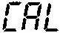

Note:(1) Meter has already been calibrated when it been sold out from the factory, normally it can be used directly.

(2) Meter only can be calibrated under the mode of , and can not be calibrated in mode of , and , must shift to mode, and again shift to the original mode after finishing calibration.
4.3. Sample Test:
4.3.1. Wash the conductivity electrode and shake off the water on it, then insert it into the solution, still it after stirring, and take the reading after “ ” appearing, which is the conductivity values of this solution.
4.3.2 Press key without releasing can display the value of the TDS, salinity and resistivity value against the measured conductivity value,and release after choosing made.
4.4. Important Statement:
4.4.1. This meter build-in below two kinds of calibration solution series, please set up in the parameters P1;
(a) (Europe & U.S.A. series) — 84μS/cm, 1413μS/cm, 12.88mS/cm and 111.9 mS/cm

(b) (China series) — 146.6μS/cm, 1408μS/cm, 12.85mS/cm and 111.3 mS/cm

4.4.2. This meter has an unique one-point calibration function, to choose the calibration solution based on the principle of the water samples and calibration solution conductivity as close as possible, in general the most common calibration solution is 1413 μS/cm. Use the equipped 2301-S conductivity electrode (K = 1 cm⁻¹), and do calibrate with 1413 μS/cm calibration solution, can use within the range of less than 100 mS/cm. Please choose refer to the Table (4-1).
Note：When you choose to use DJS-0.1-S conductivity electrode (optional accessories, K=0.1 cm⁻¹ , no temperature element), you can install the meter Manual Temperature Compensation model: long time press (press time more than 2s), at this time, the value of temperature is twinkling, press or
to change the value of temperature and then press is ok.
Table (4-1)
Measuring range | 0.05 to 20μS/cm | 0.5μS/cm to 200mS/cm
Electrode constant | K=0.1cm⁻¹(flow test) | K=1.0cm⁻¹
Calibration solution | 84μS/cm | 84μS/cm | 1413μS/cm | 12.88 mS/cm  111.9 mS/cm
Calibration indication icon | 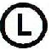 |  |  | 
4.4.3. There are two kinds of method which are standard solution calibration method and constant calibration method for conductivity electrode calibration which have been set in meter, the statement in item 4.2.“electrode calibration” is the standard calibration method, and when the accuracy of standard solution is accurate then suggest the standard solution calibration method is priority selected, it can ensure the best accuracy. If user used to use constant calibration method, please set the electrode constant in the parameter set of P5 (see P16 item4.5.6.). The two methods can choose freely and won’t influence each other. When adopting the constant calibration method, LCD won’t display the calibration indicator symbol.
4.4.4. The temperature compensation coefficient of the meter setting is 2.0%/℃ by default. However, the conductivity temperature coefficient is different for solution of different variety and concentrations, the user can refer Table (4-2), as well as the data which they own get in the experiment, to set in the parameters setting of P4. At the same time, meter will do automatic non-linear temperature compensation in the high purified water which less than 10 μ S / cm.
Note: When the coefficient of temperature compensation is set to be 0.00, that is, there is no temperature compensation when testing, the measuring value based on current temperature.
Table (4-2)
Solution | Temperature compensation coefficient
NaCl salt solution | 2.12%/℃
5%NaOH solution | 1.72%/℃
Dilute ammonia solution | 1.88%/℃
10% hydrochroric acid solution | 1.32%/℃
5% sulfuric acid solution | 0.96%/℃
4.4.5.The other parameters setting, please see the Table (4-3)
4.4.6. Special attention: when the content of parameter setting is consistent with content of default setting, conductivity measuring interface will display as picture (4-1). When the content of parameter setting is different with content of default setting, conductivity measuring interface will display as picture (4-2), the code icon will appear on the upper right of LCD, when parameters with code icon to be set more than two, LCD just display one of the code symbols, user should enter into the parameter setting interface and carefully check the contents of setting or restore the meter to default setting and again set needed parameters.
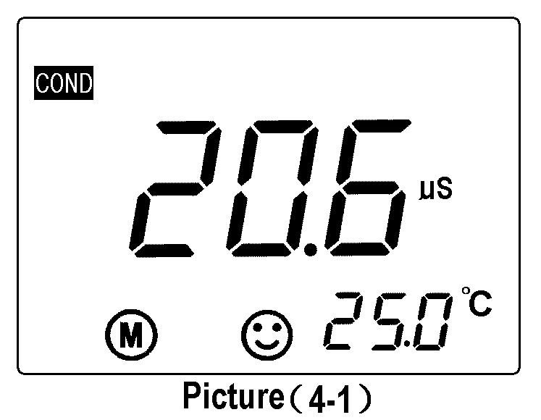
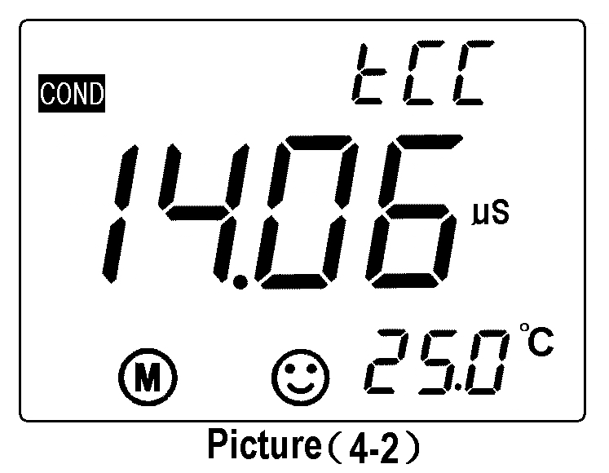
4.5. Parameter Setting:
4.5.1. Conductivity measuring parameter setting Table (Table (4-3))
Table (4-3)
Prompt Mark | Parameter Setting Items | Code | Parameter
P1 | Standard solution series selection |  | USA (84μS/cm, 1413μS/cm, 12.88 mS/cm, 111.9 mS/cm)  CH (146.6μS/cm, 1408μS/cm, 12.85mS/cm, 111.3mS/cm)
P2 | Electrode constant selection | 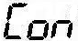 | 0.1, 1, 10
P3 | Benchmark temperature selection |  | 25℃ 20℃ 18℃
P4 | Temperature compensation coefficient setting |  | 0.00 to 9.99%
P5 | Electrode constant setting | 
P6 | Temperature unit selection |  | ℃ ℉
P7 | Backlight display time setting |  | 0-1-3-6 min
P8 | Auto power off time setting |  | 0-10-20 min
P9 | Restore to default setting |  | OFF-On
4.5.2. Conductivity calibration solution series selection (P1)
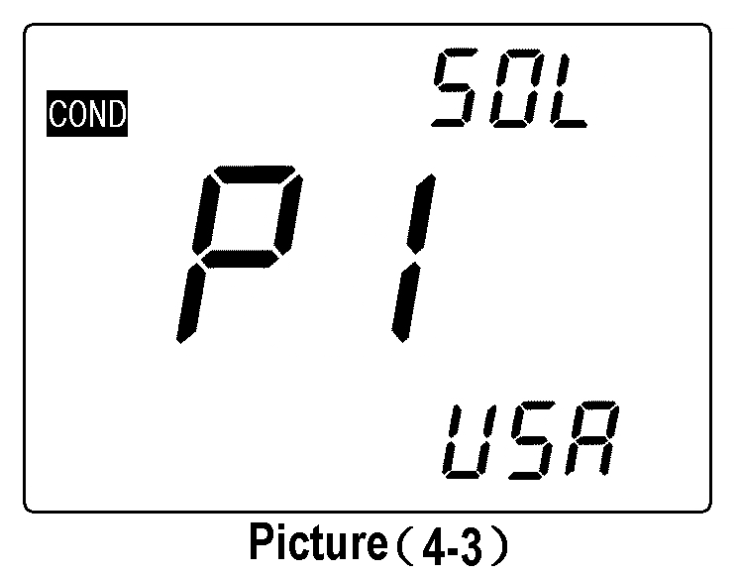
(a) Press key to enter into P1 mode, see picture (4-3);
(b) Press or key to choose the standard solution series:
— Europe & U.S.A. series — China series
(c) Press key to enter into the next parameter setting or press key return to measuring mode.
4.5.3. Electrode constant selection (P2)
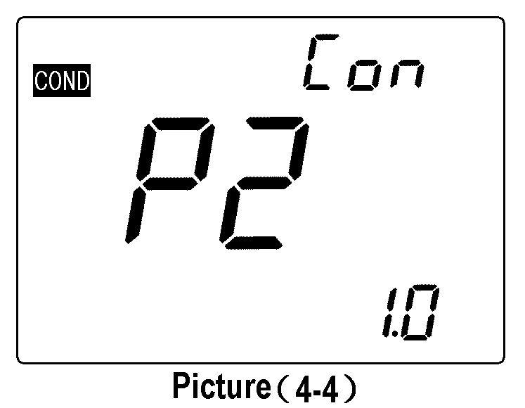
(a) Under P1 mode, press key to enter into P2 mode, see picture (4-4);
(b) Press or key to change the constant setting:
0.1→1.0→10.0.
(c) Press key to enter into the next parameter setting or press key return to measuring mode.
(d) The default setting of P2 is K=1.0.
4.5.4. Benchmark temperature selection (P3)
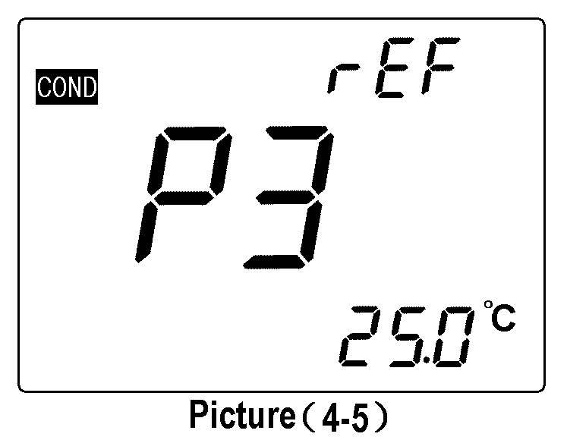
(a) Under P2 mode, press key to enter into the P3 mode, see picture (4-5);
(b) Press or key to choose the benchmark temperature: 25℃→20℃→18℃;
(c) Press key to enter into the next parameter setting or press key return to measuring mode.
(d) The default setting of P3 is 25℃.
Attention: If change the benchmark temperature to 20℃ or 18℃, the LCD will display “ ” icon in the upper-right corner when in measuring mode.
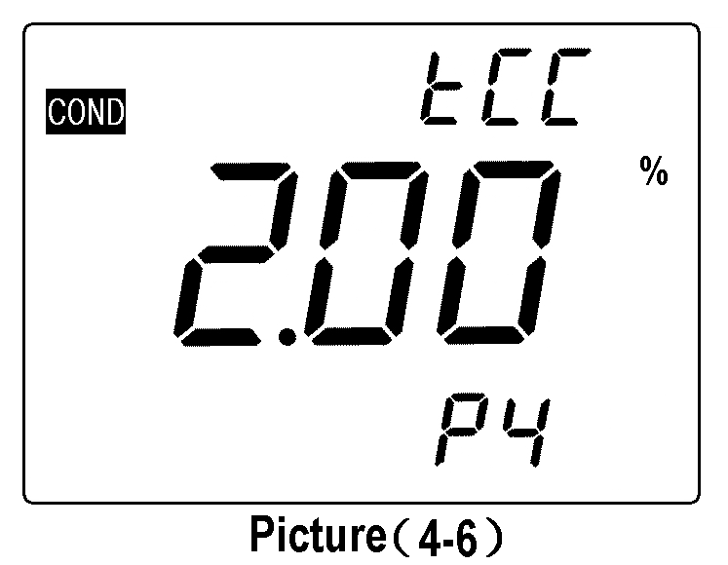
4.5.5. Temperature compensation coefficient setting (P4)
(a) Under P3 mode,press key to enter into P4 mode, shown as the picture (4-6);
(b) Press or key to change the number, the changing range of data is from 0.00 to 9.99; press or without releasing to make quickly changing.
Attention: When the number set as 0.00, means there is no temperature compensation, for details please see P12 item 4.4.4;
(c) Press key to enter into the next parameter setting or press key return to measuring mode.
(d) The default setting of P4 is 2.0%.
Attention: If change the temperature coefficient to other numerical value, upper-right corner of LCD will display “ ” icon when in measuring mode.
4.5.6. Electrode’s constant calibration setting (P5), please refer to P9 item 4.4.3.
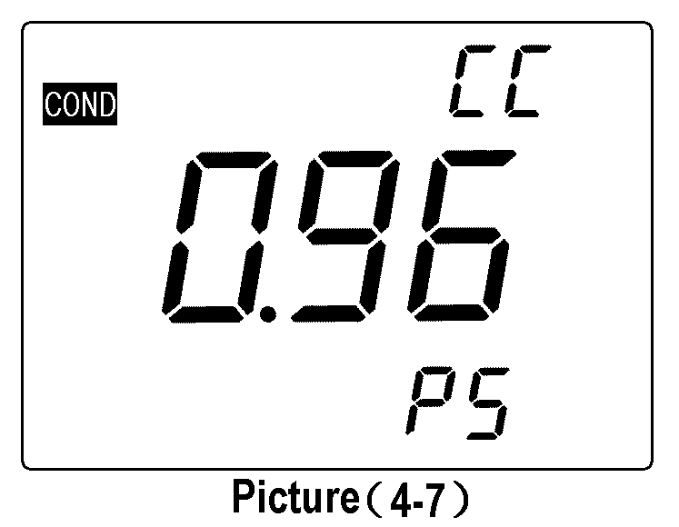
(a) Under P4 mode,press key to enter into P5 mode, LCD displaying last calibration constant. For example the 0.96cm⁻¹, shown as picture (4-7);
(b) Press or key to change number when the number is flickering, and finish setting the constant which marked on the housing of conductivity electrode.
(c) Press key to enter into the next parameter setting or press key return to measuring mode.
(d) If need to do calibration for other conductivity electrode which constant is not 1, such as conductivity electrode with constant 10.3, should enter into constant setting P2 to set the constant to be “10”, then enter into P5 mode and set the constant to be 10.3.
4.5.7. Temperature unit ℃/℉ selection (P6)
(a) Press key in mode P5 to enter into mode P6, see picture (4-8).
(b) Press or key to choose temperature unit: ℃or℉.
(c) Press key to enter into next parameter setting or press
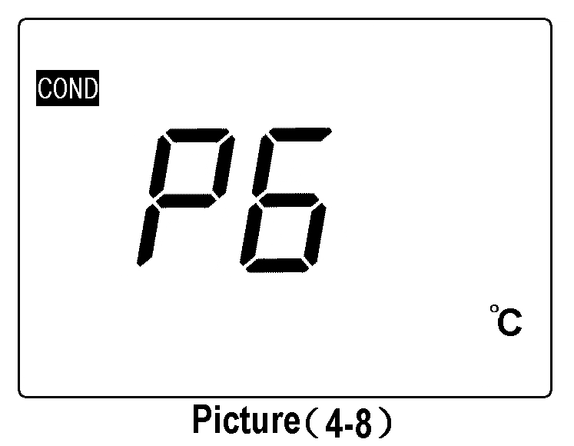
key to conform and return to measuring mode.
4.5.8. Backlight display time setting (P7)
(a) Press key in mode P6 to enter into mode P7, see picture (4-9).
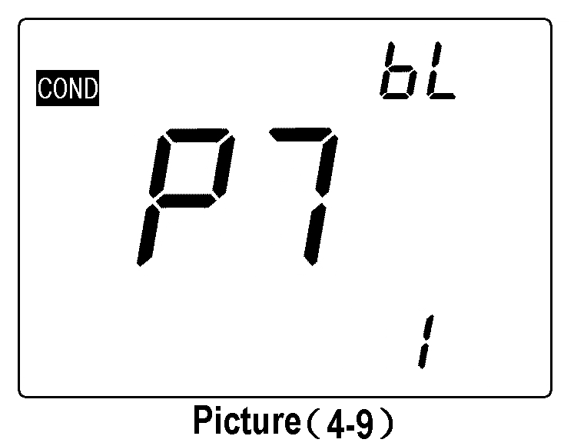
(b) Press or key to choose the time of backlight auto power off: 0 min, 1 min, 3 min or 6 min. The backlight display function will be closed if choosing a 0 min.
(c) Press key to enter into next parameter setting or press key to conform and return to measuring mode.
(d) The default setting for P7 is 1min.
4.5.9.Auto power off time setting (P8)
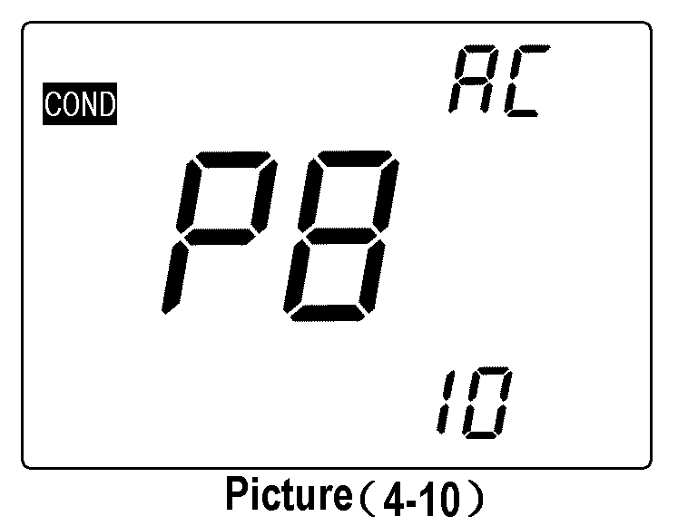
(a) Press key in mode P7 to enter into mode P8, see picture (4-10).
(b) Press or key to choose the time: 0min, 10min or 20min. The auto power off function will be closed if choosing 0min.
(c) Press key to enter into next parameter setting or press
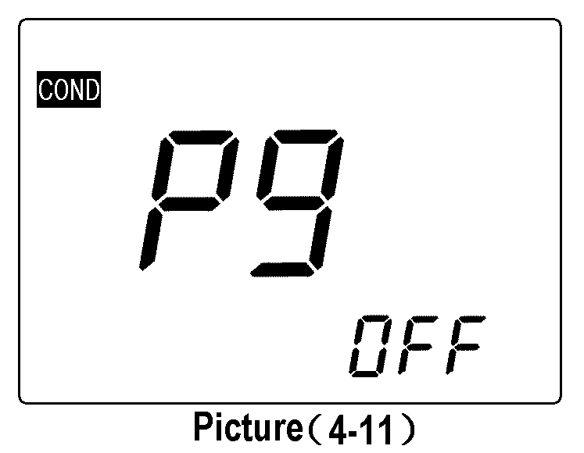
key to conform and return to measuring mode.
(d) The default setting for P8 is 10 min.
4.5.10. Restore to default setting (P9)
(a) Press key in mode P8 to enter into mode P9, see picture (4-11).
(b) Press or key to choose “ ”, means that parameters have been restored to the default setting mode, and restore to measuring mode after 2 seconds.
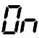
4.6. Considerations:
4.6.1. The conductivity electrode has been calibrated before meter leaving factory, user can directly use it under normal circumstance;
4.6.2. Recommended calibrating one time every month under the normal circumstances; It is necessary to calibrate the newly purchased conductivity electrode or used after a period time;
4.6.3. Keeping the conductivity electrode clean and wash it with purified water, then throw off the water on it before and after testing. It’s better to rinse electrodes with sample solution;
4.6.4. The surface of 2301-M conductivity electrode is plated with a layer of metal platinum black to used as lowering the electrode polarization, enlarge measuring range, so can not polish the surface of platinum black, only can wash it in water by shaking, in case to damage the platinum black coating; for organic stained things can be washed with hot water with detergent or alcohol.
4.6.5. Conductivity electrode before use can be immersed in water, to prevent the platinum black to be passivated, if found the platinum black plated electrode is invalid, can immerse it into 10% nitric acid solution or 10% hydrochloric acid for 2 minutes, then rinse with purified water and again test. If the situation does not improve, then need to replace platinum black, or replacing a new conductivity electrode.
4.6.6. When it appears an abnormal reading when calibrating or displaying, please set P9 as “ON” to make the meter restore to default setting mode, and then do calibrate and measure again
5. DO Measurement:

5.1. Preparation Work:
5.1.1. Check the DO500 DO electrode: see picture (5-1), screw off the bottom lid of electrode calibration cover, check whether the water stored sponge inside is soaked or not. If not, please drop some appropriate purified water, then upside down the calibration cover to remove of rest purified water (Attention: no stored water in calibration cover); repeatedly inspect the electrolyte within electrode membrane cap can’t have air bubbles (except the smaller air bubbles). If there are lager air bubbles, please unplug the membrane cap and add electrolyte and screw on.
5.1.2. Press key to turn on the meter, connect the DO500 electrode into meter to polarize for 5 minutes.
5.1.3. Choose the units: Press to choose unit: mg/L, ppm and %.

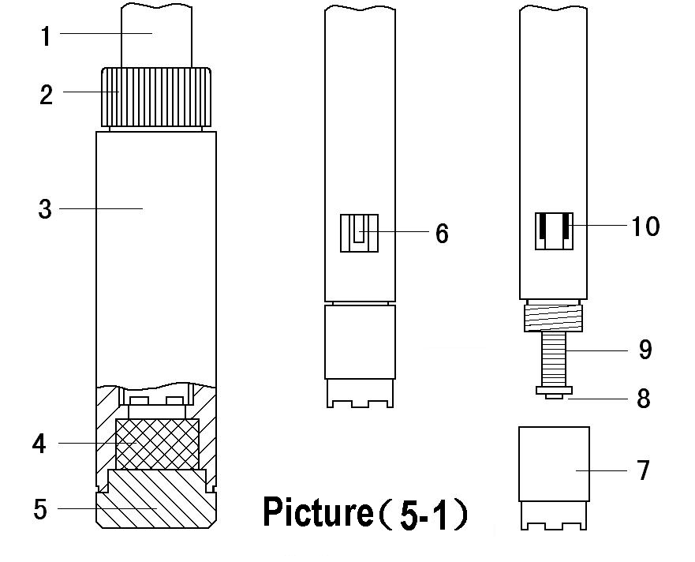

1— DO500 DO electrode
2 — Calibration cover cap
3 — Calibration cover
4 — Water stored sponge
5 — Calibration cover bottom lip
6 — Temperature electrode
7 — Membrane cap
8 — Cathode (gold slice)
9 — Anode
10 — Salinity electrode

5.2. Meter Calibration:
Press key to enter into calibration mode, upper-right corner of LCD will display a flickering “CAL”. Insert the DO electrode into calibration cover, and screw the cap of calibration cover tightly, place vertically to polarize 3 to 5 minutes, after the display values is stable and when appears the “ ” icon, again press key to calibrate. LCD will display flickering 100%, the calibration is finished after several seconds and return to the measuring mode. If the display value is unstable, please wait for several minutes and again press key until the display value is completely stable.
5.3. Water Sample Test:
5.3.1. To measure in the flowing water (water sample velocity of flow >5cm/s): Insert the DO electrode into water, water surface should excess location of the thermistor which is on the electrode, the direction for electrode and water is 45° to 75° angle, and swing slightly the electrode, then hold 3 to 5 minutes to take the reading after stable displayed.
5.3.2. To measure in static water: Insert DO electrode into water, water surface should excess location of the thermistor, the direction for electrode and water is 45° to 75° angle, quickly remove the electrode in water, the remove speed is >5cm/s, hold 3 to 5 minutes to take the reading after stable displayed;
5.3.3. To test in the slower flowing water: according to the method of item 5.3.1, but the remove speed of electrode should be faster.
5.4. Considerations:
5.4.1. The air temperature and water temperature should closer when test (≤10℃), if it is biggish different, please immerse the electrode into the sample water for about 10 minutes, then insert the electrode into the calibrate cover for 5 to 6 minutes according to item 5.2.1 and press the key to do calibration.
5.4.2. After each start-up meter must be carried out as required electrode polarization and calibration, so do not turn off the meter while using (when in the DO mode, the time for default setting for auto power off is 0).
5.4.3. During DO test, temperature effects a lot on measuring value, because the thermistor of DO electrode is installed on the electrode housing, direct touches with water, not equips in the electrolyte of internal electrode, both of them have difference for sensibility on the water temperature, generally will need 3 to 5 minutes to make the thermistor temperature and the electrolyte within electrode of the actual temperature reached unanimity, so the reading time must be > 3 minutes, or else they would have a greater error, especially when the electrode temperature and water temperature has larger difference, will need to extend the reading time;
5.4.4. DO measurement also can be affected by barometric pressure, and has biggish inaccuracy (please see Table V and Ⅵ). This meter has automatic barometric pressure compensation function, and the measuring value has been amended by the barometric pressure compensation,.
5.4.5. DO electrode can not be static test in the static water, otherwise it will lead the results to be lower.
5.4.6. When measuring, there can not have any bubbles for DO electrode and the sensitive membrane which touches with water, otherwise will affect measuring accuracy.
5.4.7. Electrode within the electrolyte can not have air bubbles (except for the smaller air bubbles), otherwise it will affect the response speed and accuracy. If a large air bubble, should screw out membrane cap, then add the electrolyte and membrane cap is screwed up;
5.4.8. Should keep the surface of DO electrode to be wet to prevent the cathode electrolyte withered, there is a piece of water stored sponge in calibration cover bottom, see picture (5-1), user must always maintain a moist sponge when the sponge is dried should be dropping some water on it (Let sponge saturated absorption, but you can not have a water flow). And tightly twist electrode cap, dissolved oxygen electrode should be kept in humid conditions.
5.4.9. The salinity electrode be installed in DO electrode (see picture (5-1)), the surface is plated with a layer of metal platinum black to reduce electrode polarization. The surface of platinum can not be rubbed. It only can be washed by shaking in water in case of damaging the platinum black coating. Wash the organic component pollution with tepid water containing detergent or with alcohol.
5.4.10. When it is abnormal for calibrating or displaying, please set the mode P7 to be “On” to restore meter to default setting state, and then do calibrate and measure.
5.5. Parameter Setting:
5.5.1. DO parameter setting table (Table (5-1))
Table (5-1)
Prompt Mark | Parameter Setting Items | Code | Parameter
P1 | Resolution selection |  | 0.01/0.1(mg/L and ppm) 0.1/1(%)
P2 | Salinity calibration
P3 | Barometric pressure setting
P4 | Temperature unit setting |  | ℃ ℉
P5 | Backlight display time setting |  | 0-1-3-6 min
P6 | Auto power off time setting |  | 0-10-20 min
P7 | Restore to default setting |  | OFF-On (shut-set)
5.5.2. Resolution selection (P1)
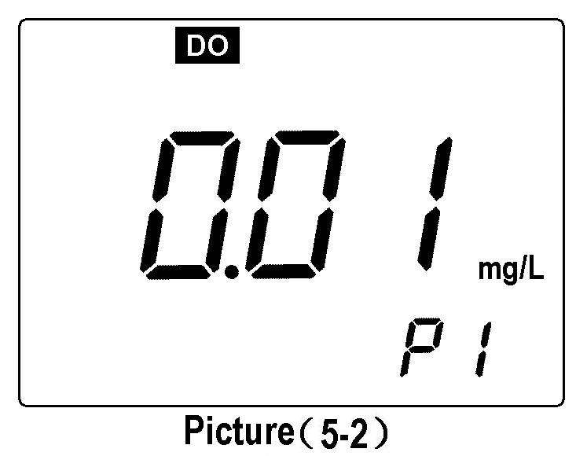
(a) Press key to enter into P1 mode, see picture (5-2);
(b) Press key to choose resolution: 0.01→0.1;
(c) Press key to enter into the next parameter setting or press return to the measuring interface.
5.5.3. Salinity calibration (P2)
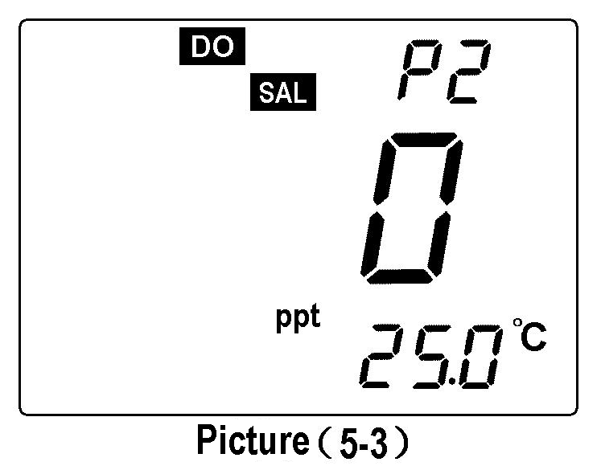
(a) Under P1 mode, press key to enter into P2 mode, shown as picture (5-3).
(b) Insert the DO electrode into 12.88mS/cm calibration solution, solution level should excess salinity electrode, still it after stirring, then press the key when the value to be stable and appears an icon “ ”, the LCD displays a twinkling “12.9”. The calibration is finished after several minutes and displays a stable salinity value.
(c) Press key to enter into the next parameter setting or press key to confirm and return to the measuring mode.
5.5.4. Barometric pressure (P3)
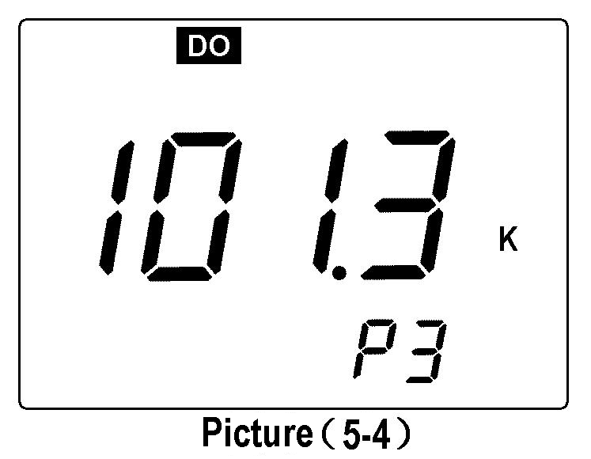
(a) Under mode P2, press key to enter into P3 mode, the LCD displays the barometric pressure measuring value set earlier (unit is kPa), such as 101.3kPa, show as picture (5-4).
(b) Press or to change according to standard barometric pressure table, and press the or without releasing to quickly change the value.
(c) Press key to enter into next parameter setting or press key to confirm and return to measuring mode.
5.5.5. Time unit℃/℉ selection (P4)
Under P3 mode, press key to enter into P4 mode, the other operation, please refer to P16 item 4.5.7.
5.5.6. Time setting for backlight display (P5)
Under P4 mode,press key to enter into P5 mode, the other operation, please refer to P16 item 4.5.8.
5.5.7. Time setting for auto power off (P6)
Under P5 mode,press key to enter into P6 mode, the other operation, please refer to P17 item 4.5.9.
Note: The default setting for DO measurement mode is 0, that is, the function of auto power off is closed.
5.5.8. Restore to default setting (P7)
Under P6 mode,press key to enter into P7 mode, the other operation, please refer to P17 item 4.5.10.
5.6. Change the Membrane Cap:
When electrode response time to be longer, and displaying value appear obviously error, or when sensitive membrane of DO electrode has a wrinkle, crack or damaged, should replace a membrane cap according to the following steps.
(a) Remove the membrane cap;
(b) Wash the electrode without membrane cap with purified water and throw off the water on it.
(c) Polish lightly on cathode surface (gold slice) with a piece of clear velvet or tissue;
(d) Inject electrolyte into a new membrane cap slowly and do not has any air bubbles appeared. After injected, should check the electrolyte to see whether there are air bubbles in it. If found there are air bubbles, please carefully knock on the membrane cap to dispel them.
(e) Put membrane cap on the table and set in the electrode vertically, slowly clockwise twist, then twist tightly. Temporality, redundant electrolyte will squeeze out, please wipe it out with tissue and clear it in the purified water.
(f) Check there is no air bubbles in electrolyte (beside the smaller air bubbles), otherwise, re-assembly is needed.
(g) No touching the sensitive membrane when use the electrode and replace the membrane cap for the sweat and grease will effect the quality of membrane and decrease the rate of oxygen permeability.
5.7. Zero Oxygen Calibration:
Generally need to do zero oxygen calibration in the situation of replacing electrode, replacing membrane cap, and long time without using. Usually no need to do zero oxygen calibration. The meter has already been made zero oxygen calibration before leaving factory, so for the initially use, needn’t to be calibrated. To do zero oxygen calibration by following below steps:
(a) Preparing 100mL anaerobic water: In 100 mL beaker add 5g anhydrous sodium sulfite (Na₂SO3), plus 100 mL purified water stir to dissolve, anaerobic water is effective within 24 hours.
(b) To polarize electrode by connecting it into meter for 15min, and to do calibration according to the item 5.2.1;
(c) Put the electrode into anaerobic water, press key to make meter enter into calibration mode, when displaying value is ≤ 0.15mg/L (≤5min), again press
key to calibrate, then the LCD displays a flickering 0.0%, the calibration finishes after several seconds and the meter displays 0.00 mg/L, then wash the electrode with purified water;
(d) If the meter displayed value ≤0.02mg/L within 5 minutes, means the response speed of meter and residual current are good, need not to do zero oxygen calibration, press
key to return to measuring mode.
(e) If the value of meter is displayed as >0.15 mg/L after 5 minutes, means the response speed of meter is slow and large residual current, at this time can change the membrane cap or remove the membrane cap and take out the polishing paper in the accessories to lightly wipe the catholic of gold plane (to the surface along the arc of gold-polished), and clean surface of cathode with soft cloth to tissue), and wash electrode with purified water and throw off the water on it. Add some electrolyte into the membrane cap, re-assembly and screw tightly, then to do full scale and zero oxygen calibration. To do zero oxygen calibrtion by the following steps:
(a) Preparing 100mL anaerobic water: In 100 mL beaker add 5g anhydrous sodium sulfite (Na₂SO₃), plus 100 mL purified water stir to dissolve, anaerobic water is effective within 24 hours.
(b) To polarize electrode by connecting it into meter for 15min, and to do calibration according to the item 5.2.1;
(c) Put the electrode into anaerobic water, press key to make meter enter into calibration mode, when displaying value is ≤ 0.15mg/L (≤5min), again press
key to calibrate, then the LCD displays a twinkling 0.0%, the calibration finishes after several seconds and the meter displays 0.00 mg/L, then wash the electrode with purified water;
(d) If the meter displayed value ≤0.02mg/L within 5 minutes, means the response speed of meter and residual current are good, need not to do zero oxygen calibration, press key to return to measuring mode.
(e) If the value of meter is displayed as >0.15 mg/L after 5 minutes, means the response speed of meter is slow and large residual current, at this time can change the membrane cap or remove the membrane cap and take out the polishing paper in the accessories to lightly wipe the catholic of gold plane (to the surface along the arc of gold-polished), and clean surface of cathode with soft cloth to tissue), and wash electrode with purified water and throw off the water on it. Add some electrolyte into the membrane cap, re-assembly and screw tightly, then to do full scale and zero oxygen calibration according to item 5.2. and 5.7.

5.8. Salinity Calibration:
The meter has function of salinity automatic compensation, but this salinity calibration is just need to apply in replacing a new electrode and long-time without using. In general do not need to do salinity calibration. The meter has already been made salinity calibration before leaving factory, so it is no need to do salinity calibration for fist time using. For the procedure of salinity calibration, please refer to P23 item 5.5.3.
5.9. Barometric Pressure Setting:
The meter has the function of manual barometric pressure compensation. It is suggested to reset the value according to the standard barometric pressure table when there is a biggish change of barometric pressure while using to ensure the accuracy of barometric pressure compensation. For the procedure of barometric pressure calibration, please see P24 item 5.5.4.

6. Meter’s Complete Kit:

6.1. Model SX726 Conductivity/DO meter
1 set
1 pc
1pc
1btl
6.2. 2301-S plastic conductivity electrode
6.3. DO500 DO electrode
6.4. 1413μS/cm conductivity standard solution (50mL)
6.5. DO503 membrane cap (DO electrode use) 3pcs
6.6. DO502 DO electrode inner solution (30mL) 1btl
6.7. Cathode polishing paper 2pcs
6.8. Screw driver 1pcs
6.9. Spare AA batteries 2pcs
6.10. Operation manual 1pcs
6.11. Carrying case 1pcs

7. Warranty:

7.1. We warrant this meter to be free of charge maintain, replace the parts or products under normal using circumstances, from purchased time within one year caused by manufacturing bad and unable to work.
7.2. Attached other electrodes do not belong to this warrant range, besides the temperature electrode. But, if the newly purchased electrode went wrong without using, it’s free of charge to maintain and replace.
7.3. The above warranty is not apply to defects resulting from action of user such as misuse, improper wiring, operation outside of specification, improper maintenance or repair, or unauthorized modification.

Table І Meter Parameter Setting Table

Mode | Prompt Mark | Parameter Setting Items | Code | Parameter
Conductivity | P1 | Standard solution series selection |  | USA(84μS/cm, 1413μS/cm, 12.88 mS/cm, 111.9 mS/cm)  CH（146.6μS/cm, 1408μS/cm, 12.85mS/cm, 111.3 mS/cm）
Conductivity | P2 | Electrode constant selection |  | 0.1, 1, 10
Conductivity | P3 | Benchmark temperature selection |  | 25℃ 20℃ 18℃
Conductivity | P4 | Temperature compensation coefficient setting |  | 0.00 to 9.99%
Conductivity | P5 | Electrode constant setting
Conductivity | P6 | Temperature unit selection |  | ℃ ℉
Conductivity | P7 | Backlight display time setting |  | 0-1-3-6min
Conductivity | P8 | Auto power off time setting |  | 0-10-20min
Conductivity | P9 | Restore to default setting |  | OFF-On (shut-set)
Dissolved Oxygen | P1 | Resolution selection |  | 0.01/0.1(mg/L and ppm) 0.1, 1(%)
Dissolved Oxygen | P2 | Salinity calibration
Dissolved Oxygen | P3 | Barometric pressure setting
Dissolved Oxygen | P4 | Temperature unit selection |  | ℃ ℉
Dissolved Oxygen | P5 | Backlight display time setting |  | 0-1-3-6min
Dissolved Oxygen | P6 | Auto power off time setting |  | 0-10-20min
Dissolved Oxygen | P7 | Restore to default setting |  | OFF-On (shut-set)
Table Ⅱ Meter Restore to Default Setting Table

Mode | Prompt Mark | Parameter Setting Items | Default Setting Content | Non Default Setting Icon
Conductivity | P2 | Electrode constant type selection | K=1
Conductivity | P3 | Benchmark temperature selection | 25℃
Conductivity | P4 | Temperature compensation coefficient setting | 2.0%
Table Ⅲ Code Icon and Abbreviation Table
Explanation
English
Code and Abbreviation
Conductivity
Dissolved Oxygen
Resistivity
Total Dissolved Solid
Salinity
Standard solution
Solution
China series standard
China
Europe & U.S.A series standard
USA
Temperature compensation coefficient setting
Temperature compensation coefficient setting
Coefficient
Electrode constant selection
Constant

End
Calibration
Benchmark temperature selection
Temperature Reference
Electrode constant setting
Constant Calibration

Table Ⅳ Content of Saturated Oxygen in Water at Different Temperature

Temperature  ℃ | DO  mg/L | Temperature  ℃ | DO  mg/L | Temperature  ℃ | DO  mg/L
0 | 14.64 | 16 | 9.86 | 32 | 7.30
1 | 14.22 | 17 | 9.66 | 33 | 7.18
2 | 13.82 | 18 | 9.46 | 34 | 7.07
3 | 13.44 | 19 | 9.27 | 35 | 6.95
4 | 13.09 | 20 | 9.08 | 36 | 6.84
5 | 12.74 | 21 | 8.90 | 37 | 6.73
6 | 12.42 | 22 | 8.73 | 38 | 6.63
7 | 12.11 | 23 | 8.57 | 39 | 6.53
8 | 11.81 | 24 | 8.41 | 40 | 6.43
9 | 11.53 | 25 | 8.25 | 41 | 6.34
10 | 11.26 | 26 | 8.11 | 42 | 6.25
11 | 11.01 | 27 | 7.96 | 43 | 6.17
12 | 10.77 | 28 | 7.82 | 44 | 6.09
13 | 10.53 | 29 | 7.69 | 45 | 6.01
14 | 10.30 | 30 | 7.56
15 | 10.08 | 31 | 7.43

TableⅤ Content of Saturated Oxygen at Different Barometric Pressure

Barometric Pressure |  | Dissovled Oxygen (mg/L)
mmHg | kPa | 15℃ | 25℃ | 35℃
750 | 100.00 | 9.94 | 8.14 | 6.85
751 | 100.13 | 9.96 | 8.15 | 6.86
752 | 100.26 | 9.97 | 8.16 | 6.87
753 | 100.40 | 9.98 | 8.17 | 6.88
754 | 100.53 | 9.99 | 8.18 | 6.89
755 | 100.66 | 10.00 | 8.20 | 6.90
756 | 100.80 | 10.01 | 8.21 | 6.91
757 | 100.93 | 10.03 | 8.22 | 6.92
758 | 101.06 | 10.04 | 8.23 | 6.93
759 | 101.20 | 10.07 | 8.24 | 6.94
760 | 101.33 | 10.08 | 8.25 | 6.95
761 | 101.46 | 10.09 | 8.26 | 6.96
762 | 101.60 | 10.11 | 8.27 | 6.97
763 | 101.73 | 10.12 | 8.28 | 6.98
764 | 101.86 | 10.14 | 8.30 | 6.99
765 | 102.00 | 10.15 | 8.31 | 7.00
766 | 102.13 | 10.16 | 8.32 | 7.01
767 | 102.26 | 10.18 | 8.33 | 7.02
768 | 102.40 | 10.19 | 8.34 | 7.02
769 | 102.53 | 10.21 | 8.35 | 7.03
770 | 102.66 | 10.22 | 8.36 | 7.04
771 | 102.80 | 10.23 | 8.37 | 7.05
772 | 102.93 | 10.25 | 8.39 | 7.06
773 | 103.06 | 10.26 | 8.40 | 7.07
774 | 103.19 | 10.28 | 8.41 | 7.08
775 | 103.33 | 10.29 | 8.42 | 7.09

Conversion between mmHg and kPa: mmHg×0.13333=kPa
DO_{pt} = P×DO_{t} ÷ 760
Note: DO_{pt} — DO concentration under temperature t, barometric pressure P, mg/L;
P— Barometric pressure, mmHg;
DO_{t} — DO concentration under temperature t, barometric pressure 760mmHg, mg/L;
760 — Barometric pressure, mmHg.

TableⅥ Content of Oxygen at Different Altitude

Altitude |  | Barometric Pressure |  | DO | Altitude |  | Barometric Pressure |  | DO
Foot | meter | kPa | mmHg | mg/l | Foot | meter | kPa | mmHg | mg/l
0 | 0 | 101.3 | 760 | 8.25 | 7500 | 2287 | 77.1 | 579 | 6.28
500 | 152 | 99.34 | 746 | 8.09 | 8000 | 2439 | 75.63 | 568 | 6.16
1000 | 305 | 97.6 | 733 | 7.95 | 8500 | 2591 | 74.44 | 559 | 6.06
1500 | 457 | 95.87 | 720 | 7.81 | 9000 | 2744 | 72.97 | 548 | 5.94
2000 | 610 | 94.28 | 708 | 7.68 | 9500 | 2896 | 71.64 | 538 | 5.83
2500 | 762 | 92.54 | 695 | 7.54 | 10000 | 3049 | 70.17 | 527 | 5.71
3000 | 915 | 90.95 | 683 | 7.41 | 10500 | 3201 | 68.84 | 517 | 5.61
3500 | 1067 | 89.35 | 671 | 7.28 | 11000 | 3354 | 67.38 | 506 | 5.49
4000 | 1220 | 87.75 | 659 | 7.15 | 12000 | 3659 | 66.58 | 500 | 5.42
4500 | 1372 | 86.15 | 647 | 7.02 | 13000 | 3963 | 65.78 | 494 | 5.36
5000 | 1524 | 84.56 | 635 | 6.89 | 14000 | 4268 | 64.98 | 488 | 5.29
5500 | 1677 | 83.09 | 624 | 6.77 | 15000 | 4573 | 64.18 | 482 | 5.23
6000 | 1829 | 81.63 | 613 | 6.65 | 16000 | 4878 | 63.38 | 476 | 5.16
6500 | 1982 | 80.03 | 601 | 6.52 | 17000 | 5183 | 62.58 | 470 | 5.10
7000 | 2134 | 78.56 | 590 | 6.40 | 18000 | 5488 | 61.79 | 464 | 5.03

Shanghai San-Xin Instrumentation, Inc.

Add: 3/F. Building No.4, No. 471 Guiping Road, Shanghai, China. 200233
Tel: +86-21-63362480 Fax: +86-21-64956880
Website: www.shsan-xin.com E-mail: wxmab@shsan-xin.com

