

Model SX751
pH/ORP/Conductivity/DO

Meter

Operation Manual

Shanghai San-Xin Instrumentation Inc.

SX700 Series of Portable Meters

1. Model SX711 pH / mV Meter
2. Model SX712 ORP Meter
3. Model SX713 Conductivity / TDS / Salinity / Resistivity Meter
4. Model SX716 DO Meter
5. Model SX721 pH / ORP Meter
6. Model SX723 pH /mV / Conductivity Meter
7. Model SX725 pH / mV / DO Meter
8. Model SX726 Conductivity / DO Meter
9. Model SX731 pH / ORP / Conductivity Meter
10. Model SX736 pH / mV / Conductivity / DO Meter
11. Model SX751 pH / ORP / Conductivity / DO Meter

Contents

1. Summary ---------------------------------------------------------------------------------------------
4
6
6
6
6
6
7
7
7
7
8
9
10
10
10
12
12
15
17
18
18
18
19
20
20
20
21
2. Technical Parameters -------------------------------------------------------------------------------
2.1. pH -------------------------------------------------------------------------------------------------
2.2. (ORP) ---------------------------------------------------------------------------------------------
2.3. Conductivity -------------------------------------------------------------------------------------
2.4. Dissolved Oxygen -------------------------------------------------------------------------------
2.5. Other Technical Parameters --------------------------------------------------------------------
2.6. Working Condition ------------------------------------------------------------------------------
3. Meter Overview -------------------------------------------------------------------------------------
3.1. LCD Display -------------------------------------------------------------------------------------
3.2. Operation Keys ----------------------------------------------------------------------------------
3.3. The Storing, Displaying and Clearing Measuring Information -----------------------------
4. pH Measurement ------------------------------------------------------------------------------------
4.1. Preparation -------------------------------------------------------------------------------------
4.2. Meter Calibration -------------------------------------------------------------------------------
4.3. Sample Test --------------------------------------------------------------------------------------
4.4. Parameter Setting --------------------------------------------------------------------------------
4.5. Considerations -----------------------------------------------------------------------------------
4.6. The Self-diagnose Information ----------------------------------------------------------------
5. ORP Measurement ----------------------------------------------------------------------------------
5.1. Sample Test --------------------------------------------------------------------------------------
5.2. Considerations -----------------------------------------------------------------------------------
5.3. Parameter Setting --------------------------------------------------------------------------------
6. Conductivity Measurement ------------------------------------------------------------------------
6.1. Preparation ------------------------------------------------------------------------------------------
6.2. Meter Calibration --------------------------------------------------------------------------------
6.3. Sample Test --------------------------------------------------------------------------------------
6.4. Important Statement -----------------------------------------------------------------------------
21
23
26
27
27
28
29
29
31
33
33
34
35
35
36
6.5. Parameter Setting --------------------------------------------------------------------------------
6.6. Considerations -----------------------------------------------------------------------------------
7. DO Measurement -----------------------------------------------------------------------------------
7.1. Preparation Work --------------------------------------------------------------------------------
7.2. Meter Calibration --------------------------------------------------------------------------------
7.3. Water Sample Test -------------------------------------------------------------------------------
7.4. Considerations -----------------------------------------------------------------------------------
7.5. Parameter Setting --------------------------------------------------------------------------------
7.6. Change the Membrane Cap --------------------------------------------------------------------
7.7. Zero Oxygen Calibration -----------------------------------------------------------------------
7.8. Salinity Calibration -----------------------------------------------------------------------------
7.9 Atmospheric Pressure Calibration ----------------------------------------------------------------
8. Meter’s Complete Kit ------------------------------------------------------------------------------
9. Warranty ----------------------------------------------------------------------------------------------
TableⅠ Meter Parameter Setting Table
TableⅡ Meter Restore to Producer Setting Table
Table Ⅲ Content of Saturated Oxygen in Water at Different Temperature
Table Ⅳ Content of Oxygen at Different Altitude
Table V Code Icon and Abbreviation Table
TableⅥ Content of Saturated Oxygen at Different Atmospheric Pressure

1. Summary:

Thanks for buying and using the model SX751 pH/ORP/Conductivity/DO Meter (the following called “meter” in short).
Before using this meter, please read the operation manual carefully in order to help use and maintain it correctly. On the basis of improving instrument of performance constantly, we reserve the right of changing the content of this manual and accessories in case of not notifying in advance.
This meter is a perfect combination with the most advanced electronic technology, sensor technology and software design. The meter can measure the parameters of pH, ORP, conductivity, TDS, salinity, resistivity, DO and temperature for high accuracy water solution. It is the best portable water analysis meter with the highest performance and the lowest cost. It is suitable for the trade such as the mining industry, power plant, water treatment projects and environmental protection, etc., especially has more extensive application in the field and spot test.
Built-in microprocessor chip, beautiful appearance, multi-functional and easy to use, this meter has the following prominent features:
1.1. Multi-parameter meter, equipped with pH electrode, ORP Electrode, conductivity electrode, temperature electrode, DO electrode, when connect the electrode to the meter, the meter can automatically know the electrode, easy to use.
1.2. Built-in microprocessor chip.. Its features up to automatic calibration, automatic temperature compensation, data storage, auto power off, low voltage indication, function setting and automatic self-diagnose etc.
1.3. Adopts digital filter and step slipping technology to intelligently improve meter’s response speed and result accuracy. “ ” will appear when reading to be stable.

1.4. Automatically recognize 13 kinds of pH standard buffer solution. User can choose anyone from three series of buffer solutions: Europe & U.S.A. series, NIST series, China series.
1.5. High purified water and ammonia added purified water pH measuring mode can be set up, for this two special pH measuring modes, besides the general slope temperature compensation, also added function of nonlinearity solution temperature compensation to make measurement more accurate, especially suitable for the fields of electric power and petrochemical etc.
1.6. Adopts advanced automatic frequency convertible and voltage regulation technology to enlarge the measuring range of conductivity electrode which constant K=1 to 10 times. It can meet measuring accuracy requirement for range within 0 to 200mS/cm by using only one-point calibration. It is the particular one–point calibration function for this meter.
1.7. Automatically recognize 8 kinds of conductivity standard solution. User can choose anyone from two series of standard solutions: Europe & USA series and CHINA series.
1.8. Automatically select conductivity measuring range, the meter will do non-linearity temperature compensation test for purified and high purified water less than 10uS/cm, which greatly improve the measuring accuracy. It is especially suitable for use in fields of electric power, microelectronics and medicine.
1.9. Equips new type of DO electrode with temperature and salinity sensor which has function of automatic temperature compensation and automatic salinity compensation as well as manual Atmospheric pressure compensation inside meter, easy to use, accurate to measure.
1.10. Polarogram type DO electrode has special electrode calibration cap. Only needs 3 to 5 minutes for electrode polarization. Electrode adopts combination diaphragm cap which very convenient to use. Each DO electrode equips with three spare diaphragms caps.
1.11. Meter’s circuit board adopts SMT film-covering technology to improve meter’s production reliability.
1.12. Meter has the back light LCD display monitor.
1.13. Dustproof and waterproof meter meets IP57 rating.

2. Technical Parameters:

2.1. pH:
Measuring range | (-2.00 to 19.99) pH
Resolution | 0.1/0.01 pH
Accuracy | Meter:±0.01pH; Overall: ±0.02pH
Input current | ≤2×10⁻¹² A
Input impendance | ≥1×10¹² Ω
Stability | ±0.01 pH/3h
Temp. compensation range | (0 to 100) ℃ (automatic)
2.2. ORP(mV):
Measuring range (mV/ORP/E_{H}) | -1999 mV to 0 to 1999mV
Resolution | 1mV
Accuracy | Meter:±0.1% FS, Overall: ±15mV
2.3. Conductivity:
Measuring range | Conductivity:  (0.00 to 19.99)μS/cm (20.0 to 199.9)μS/cm  (200 to 1999)μS/cm (2.00 to 19.99) mS/cm  (20.0 to 199.9) mS/cm  TDS: (0 to 100) g/L  Salinity : (0 to 100) ppt  Resistivity: (0 to 100) MΩ·cm
Resolution | 0.01/0.1/1μS/cm 0.01/0.1 mS/cm
Accuracy | Meter:±1.0% FS, Overall:±1.5% FS
Temp. compensation range | (0 to 50) ℃ (automatic)
Electrode constant | 0.1 / 1 / 10 cm⁻¹
Benchmark temperature | 25℃, 20℃and 18℃
2.4. Dissolved Oxygen:
Measuring range | (0 to 20.00) mg/L(ppm) (0 to 200.0) %
Resolution | 0.1/0.01 mg/L(ppm) 1/0.1%
Accuracy | Meter:±0.10 mg/L, Overall:±0.40 mg/L
Response time | ≤30 s (25℃, 90% response)
Residual current | ≤0.1 mg/L
Temp. compensation range | (0 to 45) ℃ (automatic)
Salinity compensation range | (0 to 45) ppt (automatic)
Atmospheric pressure compensation range | (66 to 200) kPa (manual)
Automatic calibration | Air saturated by water; water saturated by air
Electrode type | Polarogram type
2.5. Other Technical Parameters:
Data storage | 400 groups
Storage content | Series number, measuring value measuring unit and temperature,
Power | Two AA batteries (1.5V x2)
Size and weight | (360 x 270x 76) mm/1.7kg
Quality and safety certification | ISO9001:2000, CE and CMC
2.6. Working Condition:
Environment temperature | 5 to 35 ℃ (0.01 grade)
Environmental humidity | ≤85%
IP rating | IP57 Dustproof and waterproof

3. Meter Overview:
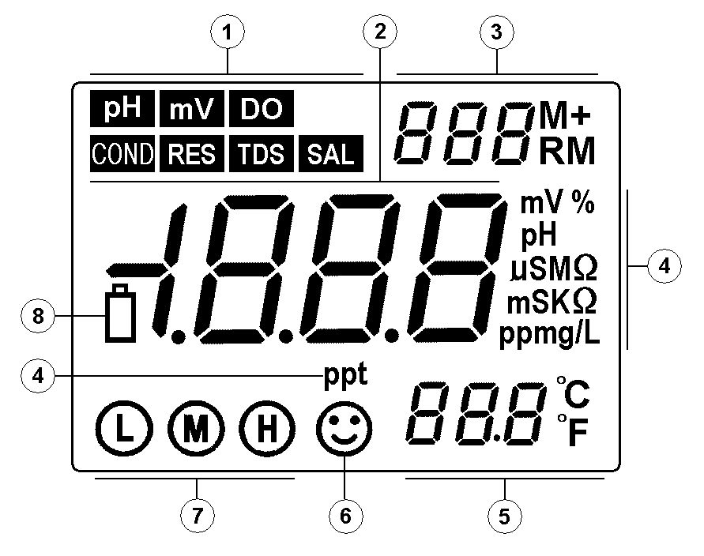
3.1. LCD Display:

① —— Parameters mode icon
② —— Measuring value
③ —— Serial number and icon as measuring value to be stored and recalled, and indication icons for special states.
M+ — measuring value to be stored icon;
RM — measuring value to be displayed icon;
④ —— Measuring unit
⑤ —— Temperature measuring value and unit Temperature compensation state icon:
⑥ —— Measuring value to be stable icon
⑦ —— Electrode calibration indicating icon
⑧ —— Indicating icon of low voltage, appears when the voltage is less than 2.6V, calling attention to change the batteries.
3.2. Operation Keys:
The meter has 5 operation keys in all.
3.2.1. — Switch on / off key

3.2.2. — Calibration key,.

(a) When in the measurement state, press this key to enter into calibration mode.
(b) When in the parameter setting state, press this key to change the number or the ON/OFF state.
3.2.3. — Function key

(a) Under measuring mode,short-time press this key (<1.5s) to display parameter icon and in turn.Press this key in a long time (>2s) to enter into the parameter setting, in turn it will display P1,P2, P3…


(b) Under others measuring mode, press this key to enter into the parameter setting mode, it will in turn display P1, P2, P3…
3.2.4. — Back light and entrance key

(a) When in the measuring state, short press (less than 1.5s) to open or close the back light display;
(b) When in the calibration state or the parameter setting state, press this key to confirm, and to make the meter enter into measuring state;
(c) When in mode, press this key to change pH resolution: 0.01→0.1 pH in turn,and release when you make a selection;
(d) When in mode, press this key to change parameter mode in turn:


(total dissolved solid)→ (salinity) → (resistivity)→ (conductivity), and release the key when you make a selection.


(e) When in mode, also press this key to change unit symbol in turn: mg/L→ppm→%, and release the key when you make a selection.

3.2.5. — The combination key of memory and recall
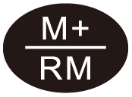
(a) When in the measurement state, press this key short time (< 1.5s) to save the measuring data. press a little longer time (＞2s) to display the stored measuring data.
(b) When in the parameter setting state, press it to change the number or ON/OFF state.
3.3. The Storing, Displaying and Clearing the Measuring Information:
3.3.1. Store the measuring information:
In the measuring mode, when the measuring data is stable and “ ” appears, short-time press key(＜1.5s), LCD will display “ M+ ” icon and storage serial number, and meanwhile memory all the measuring information. Meter can separately store 100 groups of measuring information in the mode of pH, mV, conductivity and dissolved oxygen, can totally store 400 groups.
3.3.2. Display measuring information:
(a) Under the measuring mode, press key longer time(＞2s), meter will display the last stored information, and the storage number and “RM” icon will appear in the lower right corner of the LCD, and the complete measuring information. Again short press or key, meter will in turn display all the measuring information, longer press(＞2s) or key can quickly query;
(b) In the displaying mode (there are “ RM ” and storage serial number in the upper right corner of the LCD), press key to return to the measuring mode.
3.3.3. Clear the stored measuring information:
In the displaying mode, press the key for 5 seconds, LCD will appear “ ” for 2 seconds. It means the storage has been eliminated, and returns to measuring mode.


4. pH Measurement:

4.1. Preparation Work:
4.1.1. Press key to turn on the meter. Plug the model 201T-S pH/ATC three in one combination pH electrode into meter’s socket. The meter can automatically enter into pH measuring mode.
4.2. Meter Calibration:
4.2.1. Press to enter into calibration mode, “ ” flickers on LCD indicating to enter into the first point calibration.

4.2.2. Wash the pH electrode in purified water and shake off water, then insert it into the pH7.00 buffer solution, and stir the electrode and then let it still, waiting for the data stable and “ ” appearing, then again press key , the LCD will appear a flickering 7.00 pH, calibration finishes after several seconds and appears a stable pH value and a flickering “ ”, indicating the first point calibration has been finished and then entering into the second point calibration.


4.2.3. Wash the pH electrode in purified water and shake off water, then insert it into the pH4.00 buffer solution, and stirr the electrode and then let it still, waiting for a stable data and “ ” appearing, then again press key , the LCD
will appear a flickering 4.00pH, calibration finishes after several seconds, LCD will appear a stable pH value and a flickering “ ”, indicates the second point calibration has been finished and then entering into the third point calibration.

4.2.4. Wash the pH electrode in purified water and shake off water, then insert it into the pH10.01 buffer solution, stir the electrode and then let it still, waiting “ ” to appear indicating data stable and appear, then again press key , LCD will appear a flickering 10.01 pH, calibration finishes after several seconds, appear a stable pH value and “ ” three calibration indication icon, see picture (4-1), indicating the three-point calibration has been finished and then entering into measuring mode.

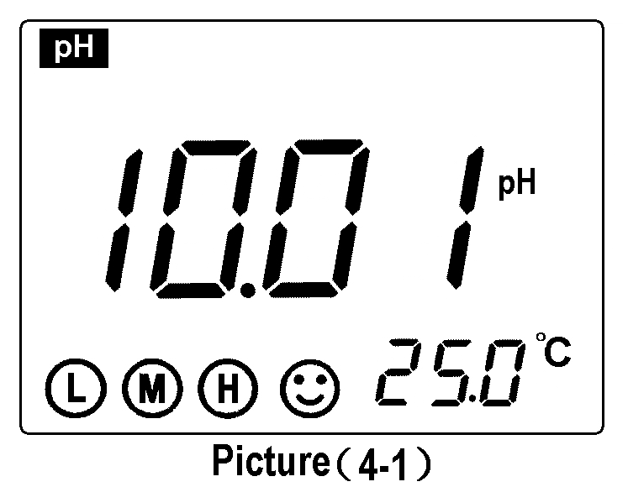
4.2.5. Note:
(a) This meter can adopt random one-point, two-point or three-point automatic calibration, after the first point calibration (see item 4.2.2.), press to confirm one-point calibration and enters into measuring mode. The indication icon “ ” for one-point calibration will appear on the lower left corner of LCD. When the measuring accuracy is ≤±0.1pH, user just need to choose one kind buffer solution to take one-point calibration according to the measuring range.

(b) After the second point calibration, (see item 4.2.3.), press to confirm two-point calibration and enter into measuring mode. The indication icon “ ” for tow-point calibration will appear on the lower left corner of LCD. User can choose pH4.00 and pH7.00 to calibrate if the measurement is just within the acidity range and choose pH7.00 and pH10.01 to calibrate if just within the alkalinity range.


(c) User should choose three-point calibration so as to reach a more accurate measurement if the measuring range is wide, or if the electrode has been used for long or has ageing phenomenon. As to the new electrode which be used for the first time, it must be calibrated by three-point calibration to keep the unanimity of the meter slope adjustment with the pH electrode.
4.3. Sample Test:
Insert pH electrode into the sample solution after washing and shake off water, stir the electrode and let it still, when the LCD appears the icon “ ” , take the reading after displaying value to be stable.
Note: According to the pH equal temperature measuring theory: the closer the temperature of the sample solution with the calibration solution, the more accurate the measuring value will be acquired. So please comply with this theory.
4.4. Parameter Setting:
4.4.1. pH measuring parameter setting Table (Table (4-1))
Table (4-1)
Prompt Mark | Parameter Setting Items | Code | Parameters
P1 | pH buffer solution series selection |  | USA (Europe & U.S.A series)  NIS (NIST series)  CH (China series)
P2 | Purified water pH temperature compensation setting |  | OFF-On (shut-set)
P3 | Ammonia added purified water pH temperature compensation setting |  | OFF-On (shut-set)
P4 | Temperature unit setting |  | ℃ ℉
P5 | Back light display time setting |  | 0-1-3-6min
P6 | Auto power off setting |  | 0-10-20min
P7 | Restore to producer setting |  | OFF-On ( shut-set)
4.4.2. pH buffer solution series selection (P1)
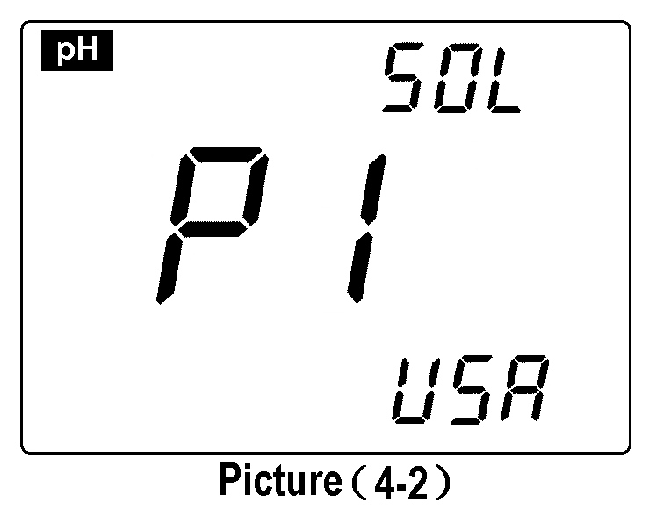
(a) Press key(>2s), meter enters into P1 mode: see picture (4-2).
(b) Press or key to choose buffer solution series:
(Europe & U.S.A series) — 1.68, 4.00, 7.00, 10.01and 12.45 pH

(NIST series) — 1.68, 4.01, 6.86, 9.18 and 12.45 pH

(China series) — 1.68, 4.00, 6.86, 9.18 and 12.46 pH

(c) Press key to enter into next parameter setting or press key to conform and return to measuring mode.
4.4.3. Purified water pH temperature compensation setting (P2)
(a) Short press key in the mode P1, the meter enters into mode P2, see picture (4-3).
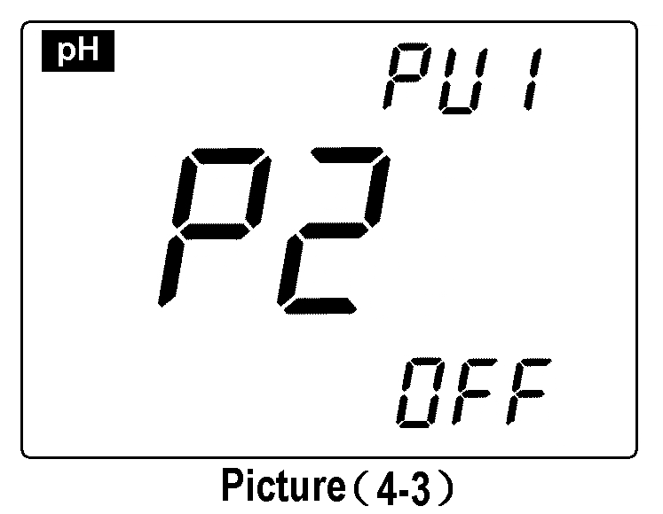
(b) Press or to choose “ ” (purified water pH temperature compensation setting) or “ ” (shut).
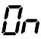
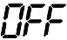
(c) Press key to enter into next parameter setting or press key to conform and return to measuring mode.
(d) The producer setting is “ OFF ”.
Note: There will appear“ ” icon in the upper right corner of the LCD if purified water temperature compensation function was set.
4.4.4. Ammonia added purified water pH temperature compensation setting (P3)
(a) Short press key in mode P2 to enter into mode P3, see picture (4-4).
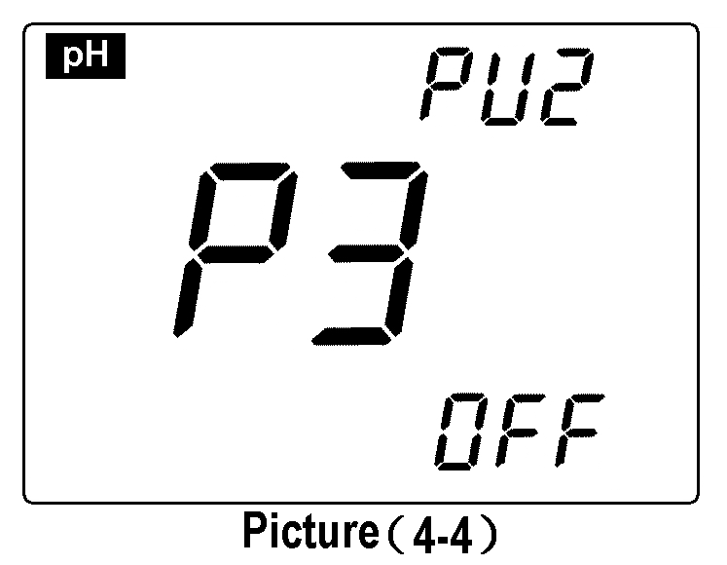
(b) Press or key to choose “ ” (ammonia added purified water pH temperature compensation setting) or “ ” (shut).
(c) Press key to enter into next parameter setting or press key to conform and return to measuring mode.
(d) The producer setting is “ OFF ”.
Note: If set the ammonia purified water pH temperature compensation function, there will appear“ ”icon in the right upper corner of the LCD when in the measuring mode.
4.4.5. Temperature unit ℃/℉ setting (P4)
(a) Short press key in mode P3 to enter into mode P4, see picture (4-5).
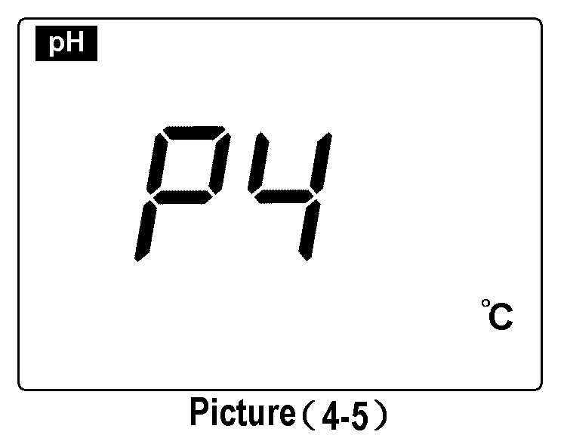
(b) Press or key to choose temperature unit: ℃or℉.
(c) Press key to enter into next parameter setting or press key to conform and return to measuring mode.
4.4.6. Back light display time setting (P5)
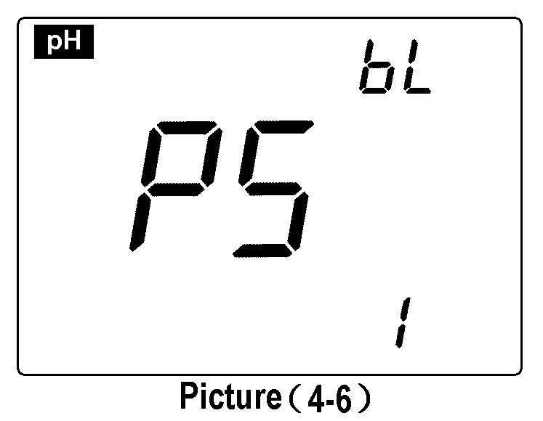
(a) Short press key in mode P4 to enter into mode P5, see picture (4-6).
(b) Press or key to choose the time of back light auto power off: 0 min, 1 min, 3 min or 6 min. The back light display function will be closed if choosing 0 min.
(c) Press key to enter into next parameter setting or press key to conform and return to measuring mode.
(d) The producer setting for P5 is 1min.
4.4.7.Auto power off time setting (P6)
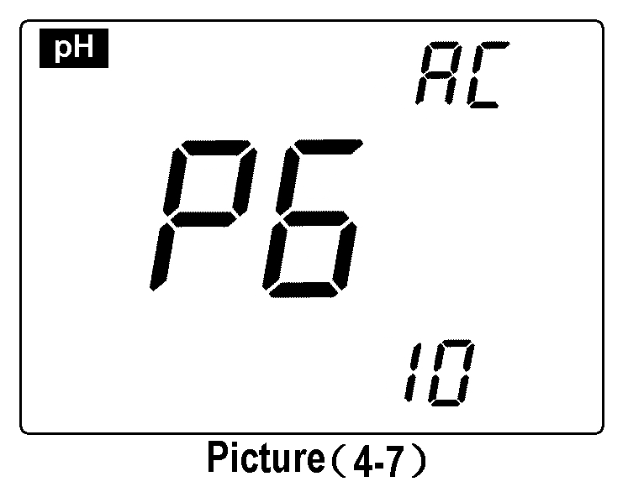
(a) Short press key in mode P5 to enter into mode P6, see picture (4-7).
(b) Press or key to choose the time: 0min, 10min or 20min. The auto power off function will be closed if choosing 0min.
(c) Press key to enter into next parameter setting or press key to conform and return to measuring mode.
(d) The producer setting for P6 is 10min.
4.4.8. Restore to producer setting (P7)
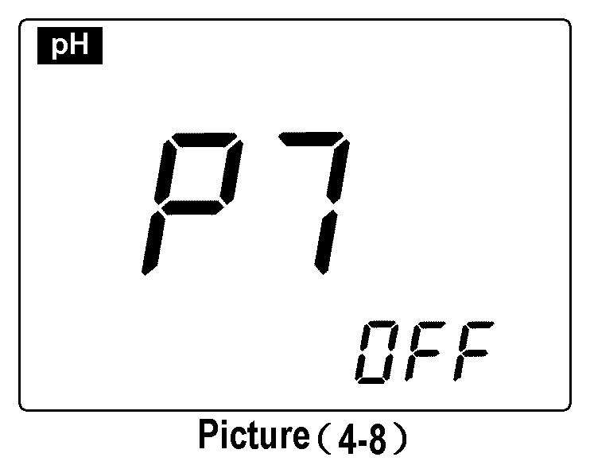
(a) Short press key in mode P6 to enter into mode P7, see picture (4-8).
(b) Press or key to choose “ ”, means that the parameters have been restored to the producer setting mode, and return to measuring mode after 2 seconds.
4.5. Considerations:
4.5.1.Calibration times of meter rely on the sample, electrode performance and required accuracy. For high accurate measurement (≤±0.02pH), which should be calibrated immediately with high accurate standard buffer solution, for general accuracy measuring (≥±0.1pH), which can be used almost one week or long time once be calibrated.
4.5.2. The meter must be recalibrated in the following situations:
(a) New changed or unused electrode for a long time;
(b) After measuring acid (pH<2) or alkaline (pH>12) solution;
(c) After measuring solution which contains fluoride and concentrated organic solution;
(d) The solution’s temperature is much different with calibration temperature.
4.5.3. The soaking solution in the protecting bottle of front pH electrode is to keep the glass bulb and junction activating. Loose the capsule, pull out the electrode and wash it in purified water before measuring. Insert the electrode and screw tight the capsule after measuring to prevent the solution leaking. If the soaking solution is turbid or moldy, please wash and change a new one at once.
4.5.4. The preparation of the soaking solution: take 25g analytical pure KCL, dissolved with purified water and dilute to 100mL. Electrode should avoid soaking in purified water protein solution and acid fluoride solution for a long time as well avoid getting touching with organic silicon lipidic matters.
4.5.5. To calibrate the meter with the given value pH buffer solution, the pH value of the standard buffer solution must be reliable so as to improve the accuracy. Buffer solution should be changed in time after many times using.
4.5.6. Always keep the meter clean and dry, especially for the socket of meter and electrode, otherwise it may lead to an inaccurate measurement or invalidity. To clean and dry them with medical cotton with dehydrated alcohol if there are any dirty.
4.5.7. The sensitive glass bulb in the front of combination electrode should not touch with hard things, any broken and rough will make the electrode invalidity. Before and after measuring, the electrode should be washed with purified water, and dry electrode after washing, don’t clean glass bulb with tissue for it will effect stability of electrode potential and enlarge response time. The electrode should be washed many times for removing the sample stuck on the electrode, or wash with suitable solvent then clean the solvent with purified water after measuring sticky sample.
4.5.8. An electrode be used for a long time, or measured solution which contains a polluting solute easily for the sensitive bulb, or a substance resulting in jam at the junction, the electrode will be getting passivated, its sensitivity will decrease and its response is getting slow, the reading are not correct. It could adopt the following method for various cases:
(a) The glass bulb is contaminated and aging: Put the electrode into 0.1mol/L dilute hydrochloric acid (Preparation: diluted 9mL hydrochloric acid to 1000mL with purified water) for 24h. Rinse it with purified water, then dipped it into the electrode dipping solution for 24h. If the passivation is serious, then user can also put the bulb of electrode into 4% HF (hydrofluoric acid) or the electrode activation solution for 3 to 5 seconds, rinsing it with purified water, and dipped it in the electrode soaking solution for 24h to renew it. Note: the electrode activation solution is available in our company.
(b) Wash for contaminated glass bulb and junction: (For reference)
Contamination Abluent
Inorganic metal oxide diluted acid less than 1mol/L
Organic lipidic matter dilute washing (weak alkaline)
Resin macromolecule matter dilute alcohol, acetone, ether
Proteinic haematocyte sediment Acidic enzymatic solution (such as dried yeast)
Kinds of paint dilute bleacher, peroxide
4.5.9. pH electrode using period is about 1 year, but its life will be shortened if using condition is poor or incorrect maintenance. So it should be replaced immediately after electrode become aging or invalid.
4.5.10. When it appears an abnormal reading when calibration or displaying, please set P7 as “ON” to restore the meter to producer setting mode, and then to calibrate and measure again.
4.6. The Self-diagnose Information:
When using, there might appear the following icons. This is the meter’s self-diagnose information, which can help to know some information about the meter or the electrode when using:
4.6.1. The stable icon -2.00 pH or the 19.99 pH — this icon appeared when the value has surpassed the measuring range. There will also appear such signs when the electrode is not well connected with the meter or when the electrode is not insertd into the solution. This is a normal phenomenon.
4.6.2. “ ” — Electrode zero potential to be exceeded (<-60mV or >60mV)

4.6.3. “ ” — Electrode slope to be exceeded (< 85% or >105%)

When appear “ ” or “ ”, the meter can not work, please take the following check:
(a) Check if the electrode bulb has air bubble, if has, please shake it hardly.
(b) Check the quality of buffer solution, if it goes bad or the value has biggish error.
(c) Set the meter to producer setting mode (for details see P15 item 4.4.8.), then recalibrate it.
If still can not recover the normal state after doing the above checking, please replace a Pt-S new pH electrode.

5. ORP Measurement:

5.1. Sample Test:
5.1.1. Press to turn on, plug the ORP combination 301 Pt-S electrode into the socket, the meter can enter ORP measuring mode automatically.
5.1.2. After plugging the model 301Pt-S ORP combination electrode, insert it into the sample solution, slowly stir and then still. When there appears a “ ” and a stable reading, that is the ORP value or the potential of the ion electrode.
5.2. Considerations:
5.2.1. The meter does not need to be calibrated when do ORP measurement. But if it is interrogative for the ORP electrode quality or the measuring result, it’s better to measure the mV value with the ORP standard solution to identify the accuracy of the ORP electrode or the meter.
Our company can supply the following ORP standard solution: 222mV(25℃)±15mV ORP standard solution (warranty 1 year), the inner solution of reference electrode is 3.5mol/L KCl.
Table (5-1)
℃ mV | ℃ mV | ℃ mV | ℃ mV
10 242 | 20 227 | 30 215 | 38 205
15 235 | 25 222 | 35 209 | 40 201
5.2.2. The clean and activation of ORP electrode: the surface of the platinum will be polluted after the ORP electrode has been using for a long time, which will lead to inaccurate measurement and slow response. It could adopt the following method for activation:
(a) For mineral pollution, insert the electrode into 0.1mol/L dilute hydrochloric acid for 30 minutes, then wash with purified water, and then insert into the electrode soaking solution for 6 hours before using.
(b) For the organic oil stain pollution, wash the platinum surface with detergent, and then insert it into the electrode soaking solution for 6 hours before using.
(c) For the seriously polluted platinum with oxidized membrane, polish the surface with toothpaste, then wash it in purified water, and then insert it into the electrode soaking solution for 6 hours before using.
5.3. Parameter Setting:
5.3.1. mV and ORP measurement parameter setting Table (Table (5-2))
Table (5-2)
Prompt Mark | Parameter Setting Items | Code | Parameters
P1 | Back light display time setting |  | 0 -1-3-6 min
P2 | Auto power off time setting |  | 0 -10-20 min
5.3.2. Back light display time setting (P1)
Press the key(>2s), the meter enters into mode P1, see detailed information in P14 item4.4.6.
5.3.3. Auto power off time setting (P2):
Short press the key in P1 mode, the meter enters into mode P2, see detailed operations in P14 item 4.4.7

6. Conductivity Measurement:

6.1. Preparation Work:
6.1.1. Press key to turn on, connect the 2301-S conductivity electrode; the meter can automatically change to the conductivity measuring mode.
6.1.2. Press key without releasing to cyclically display:
(Total Dissolved Solid) → (Salinity)→ (Resistivity)→
(Conductivity) , and release when you make a selection.
6.2. Electrode Calibration:
Press key, “ ” is flickering on the LCD, indicate enters into the calibration mode, and wash the conductivity electrode with purified water and shake off water, then insert it into the 1413μS/cm calibration solution, still it after stirring, when “ ” icon appears, means the display values is stable and again press key, LCD will display flashing “1413μS/cm ”, several seconds later the “ ” icon will appear and return to the measuring mode, at this time, LCD will display stable measuring value 1413μS/cm and calibration icon “ ”, indicating the calibration is finished. If measuring value is unstable, you can repeat calibrating steps until it is stable.

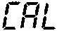
Note: Meter only can be calibrated under the mode of , and can not be calibrated in mode of , and , must shift to mode, and again shift to the original mode after finishing calibration.
6.3. Sample Test:
6.3.1. Wash the conductivity electrode and shake off the water on it, then insert it into the solution, still it after stirring, and take the reading after “ ” appears, which is the conductivity values of this solution.
6.3.2 Press key can display the value of the TDS, salinity or resistivity value which against the conductivity value, and release when you make a selection.
6.4. Important Statement:
6.4.1. This meter build-in below two kinds of calibration solution series, please set up in the parameters P1;
(a) (Europe & U.S.A. series) — 84μS/cm, 1413μS/cm,12.88mS/cm and 111.9 mS/cm
(b) (China series) — 146.6μS/cm, 1408μS/cm, 12.85mS/cm and 111.3 mS/cm
6.4.2. This meter has an unique one-point calibration function, to choose the calibration solution based on the principle of the water samples and calibration solution conductivity as close as possible, in general the most common calibration solution is 1413 μS/cm. Use the equipped 2301-S conductivity electrode (K = 1 cm⁻¹), and do calibrate with 1413 μS/cm calibration solution, can use within the range of less than 200 mS/cm. Please choose refer to the Table (6-1).
Note：When you choose to use DJS-0.1-S conductivity electrode (optional accessories, K=0.1 cm⁻¹ , no temperature element), you can install the meter Manual Temperature Compensation model: long time press (press time more than 2s), at this time, the value of temperature is twinkling, press or
to change the value of temperature and then press is ok.

Table (6-1)
Measuring range | 0.05 to 20μS/cm | 0.5μS/cm to 200mS/cm
Electrode constant | K=0.1cm⁻¹(flow test) | K=1.0cm⁻¹
Calibration solution | 84μS/cm | 84μS/cm | 1413μS/cm | 12.88 mS/cm  111.9 mS/cm
Calibration indication icon | 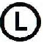 |  |  | 
6.4.3. There are two kinds of method which are standard solution calibration method and constant calibration method for conductivity electrode calibration which have been set in meter, the statement in item 6.2.“electrode calibration” is the standard calibration method, and when the accuracy of standard solution is accurate then suggest the standard solution calibration method is priority selected, it can ensure the best accuracy. If user used to use constant calibration method, please set the electrode constant in the parameter set of P5. (see P25 item6.5.6.). The two methods can choose freely and won’t influence each other. When adopting the constant calibration method, LCD won’t display the calibration indicator symbol.
6.4.4. The temperature compensation coefficient of the meter setting is 2.00%/℃ by producer. However, the conductivity temperature coefficient is different for solution of different variety and concentrations, the user can refer Table (6-2), as well as the data which they own get in the experiment, to set in the parameters setting of P4. At the same time, meter will do automatic non-linear temperature compensation in the high purified water which less than 10 μ S / cm.
Note: When the coefficient of temperature compensation is set to be 0.00, that is, there is no temperature compensation when testing, the measuring value based on current temperature.

Table (6-2)
Solution | Temperature compensation coefficient
NaCl salt solution | 2.12%/℃
5%NaOH solution | 1.72%/℃
Dilute ammonia solution | 1.88%/℃
10% hydrochroric acid solution | 1.32%/℃
5% sulfuric acid solution | 0.96%/℃
6.4.5.The other parameters setting, please see the Table (6-3)
6.4.6. Special attention: when the content of parameter setting is consistent with content of producer setting, conductivity measuring interface will display as picture (6-1). when the content of parameter setting is different with content of producer setting, conductivity measuring interface will display as picture (6-2), the code icon will appear on the upper right of LCD, when parameters with code icon to be set more than two, LCD just display one of the code symbols, user should enter into the parameter setting interface and carefully check the contents of setting or restore the meter to producer setting and again set needed parameters.
6.5. Parameter Setting:
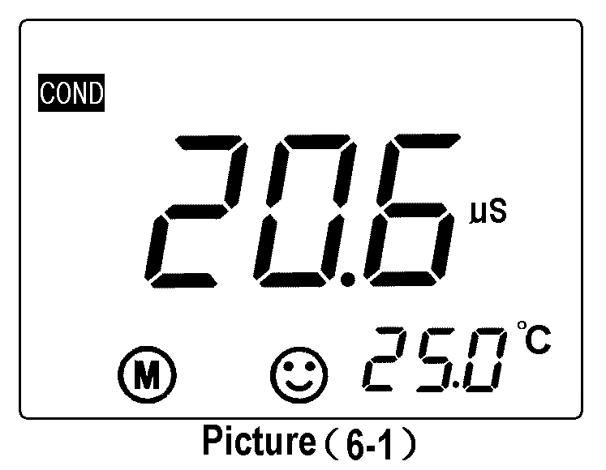
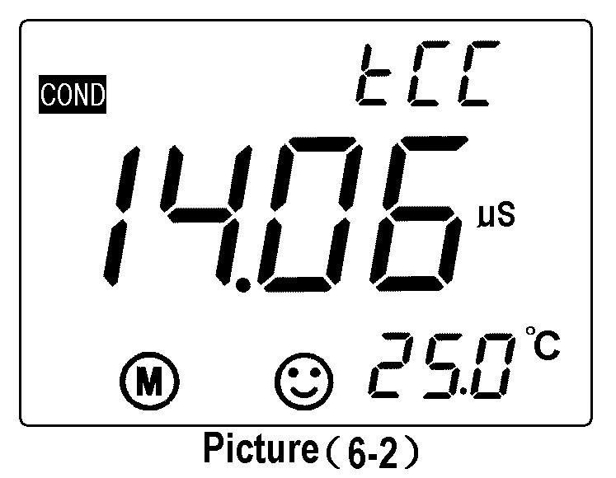
6.5.1. Conductivity measuring parameter setting Table (Table (6-3))
Table (6-3)
Prompt Mark | Parameter Setting Items | Code | Parameter
P1 | Standard solution series selection |  | USA (84μS/cm, 1413μS/cm, 12.88 mS/cm, 111.9 mS/cm)  CH (146.6μS/cm, 1408μS/cm, 12.85mS/cm, 111.3mS/cm)
P2 | Electrode constant selection | 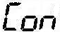 | 0.1, 1, 10
P3 | Benchmark temperature selection |  | 25℃ 20℃ 18℃
P4 | Temperature compensation coefficient setting |  | 0.00 to 9.99%
P5 | Electrode constant setting | 
P6 | Temperature unit setting |  | ℃ ℉
P7 | Back light display time setting |  | 0-1-3-6min
P8 | Auto power off time setting |  | 0-10-20min
P9 | Restore to producer setting |  | OFF-On
6.5.2. Conductivity calibration solution series selection (P1)
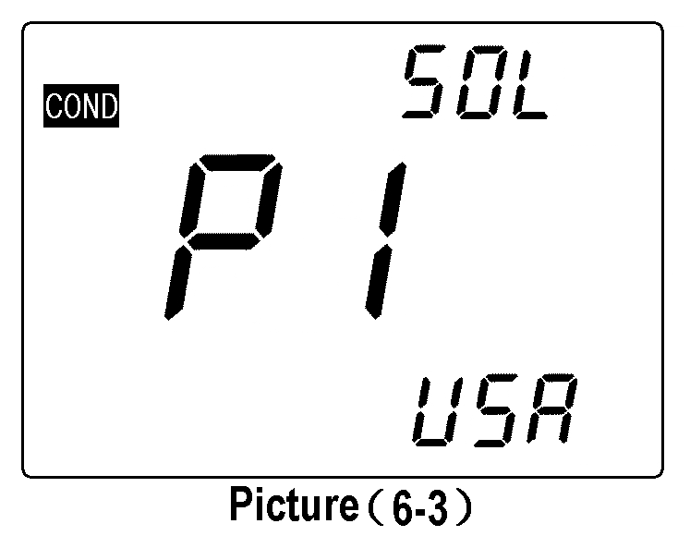
(a) Press key(>2s), meter enters into P1 mode, see picture (6-3);
(b) Press or key to choose the standard solution series:
— Europe & U.S.A. series — China series
(c) Press key to enter into the next parameter setting or press key return to measuring mode.
6.5.3. Electrode constant selection (P2)
(a) Under P1 mode to short press the key and enter into P2 mode, see picture (6-4);
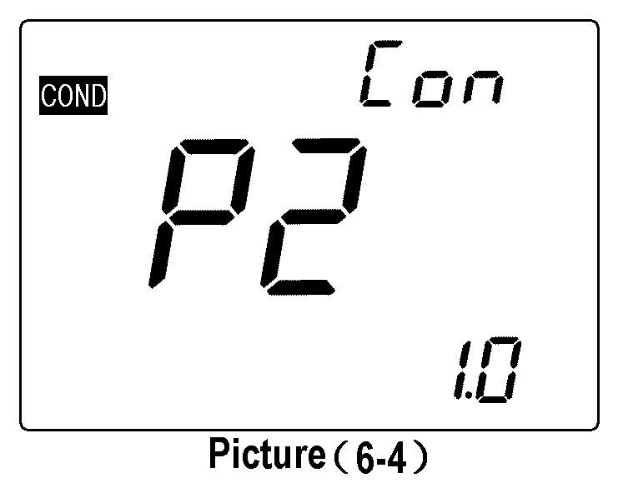
(b) Press or key to change the constant setting: 0.1→1.0→10.0.
(c) Press key to enter into the next parameter setting or press key return to measuring mode.
(d) The producer setting of P2 is K=1.0.
6.5.4. Benchmark temperature selection (P3)
(a) Under P2 mode to short press key and enter into the P3 mode, see picture (6-5);
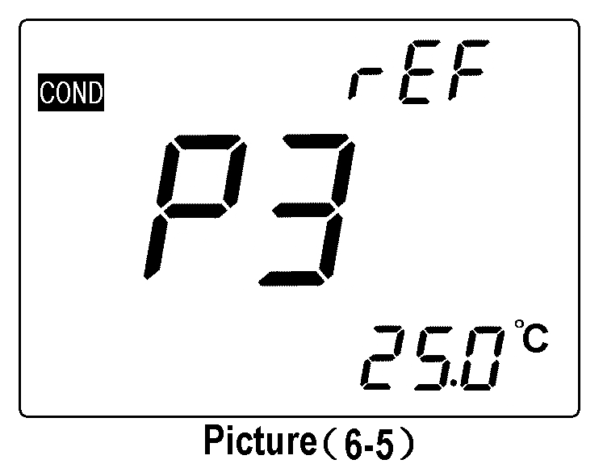
(b) Press or key to choose the benchmark temperature: 25℃→20℃→18℃;
(c) Press key to enter into the next parameter setting or press key return to measuring mode.
(d) The producer setting of P3 is 25℃.
Attention: If change the benchmark temperature to 20℃ or 18℃, the LCD will display“ ”icon in the upper-right corner when in measuring mode.
6.5.5. Temperature compensation coefficient setting (P4)
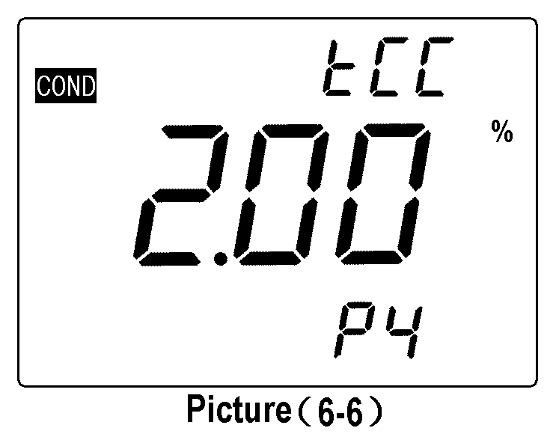
(a) Under P3 mode to short press key and enter into P4 mode, show as the picture (6-6);
(b) Press or key to change the number, the changing range of data is from 0.00 to 9.99; longer press or
to change quickly.
Attention: When the number set as 0.00, means there is no temperature compensation, for details please see P22 item 6.4.4;
(c) Press key to enter into the next parameter setting or press key return to measuring mode.
(d) The producer setting of P4 is 2.00%.
Attention: If change the temperature coefficient to other numerical value, upper-right corner of LCD will display“ ”icon when in measuring mode.
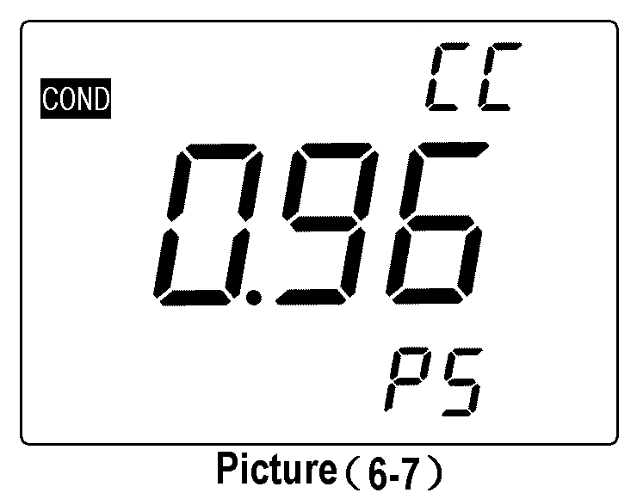
6.5.6. Constant calibration setting (P5), please refer to P22 item 6.4.3.
(a) Under P4 mode to short press key and enter into P5 mode, LCD display last calibration constant. For example the 0.96cm⁻¹ shown as picture (6-7);
(b) Press or key to change number when the number is flashing, and finish setting the constant which marked on the housing of conductivity electrode.
(c) Press key to enter into the next parameter setting or press key return to measuring mode.
(d) If need to do calibration for other conductivity electrode which constant is not 1, such as conductivity electrode with constant 10.3, should enter into constant setting P2 to set the constant to be “10”, then enter into P5 mode and set the constant to be 10.3.
6.5.7. Temperature units ℃/℉ selection (P6)
Under P5 mode to short press key and enter into P6 mode, other operation please refer to P14 item4.4.5.
6.5.8. Back light display time setting (P7)
Under P6 mode to short press key and enter into P7 mode, other operation please refer to P14 item 4.4.6.
6.5.9. Auto power off time setting (P8)
Under P7 mode to short press key and enter into P8 mode, other operation please refer to P14 item 4.4.7.
6.5.10. Restore to producer setting (P9)
Under P8 mode to short press key and enter into P9 mode, other operation please refer to P15 item 4.4.8.
6.6. Considerations:
6.6.1. The conductivity electrode has been calibrated before meter leaving factory, user can directly use it under normal circumstance;
6.6.2. Recommend calibrating one time every month under the normal circumstances; It is necessary to calibrate the newly purchased conductivity electrode or used after a period time;
6.6.3. Keeping the conductivity electrode clean and wash it with purified water, then throw off the water on it before and after testing. It’s better to rinse electrodes with sample solution;
6.6.4. The surface of 2301-S conductivity electrode is plated with a layer of metal platinum black to used as lowering the electrode polarization, enlarge measuring range, so can not polish the surface of platinum black, only can wash it in water by shaking, in case to damage the platinum black coating; for organic stained things can be washed with hot water with detergent or alcohol.
6.6.5. Conductivity electrode before use can be immersed in water, to prevent the platinum black to be passivated, if found the platinum black plated electrode is invalid, can immerse it into 10% nitric acid solution or 10% hydrochloric acid for 2 minutes, then rinse with purified water and again test. If the situation does not improve, then need to replace platinum black, or replacing a new conductivity electrode.
6.6.6. When it appears an abnormal reading when calibrating or displaying, please set P9 as “ON” to make the meter restore to producer setting mode, and then do calibrate and measure again.

7. DO Measurement:

7.1. Preparation Work:
7.1.1. Check the DO500 DO electrode: see picture (7-1), screw off the bottom lid of electrode calibration cover, inspect whether the water stored sponge inside is soaked. If it is not soaked, please drop some appropriate purified water, then upside down the calibration cover to remove of rest purified water (Attention: no stored water in calibration cover); repeatedly inspect the electrolyte within electrode membrane cap can’t have air bubbles (except the smaller air bubbles). If there are lager air bubbles, please screw off the membrane cap, add electrolyte and screw on.
7.1.2. Press key to turn on, the meter display the DO measuring mode,then connect the DO500 electrode to meter to polarize for 5 minutes
7.1.3. Choose the units: longer press to choose unit: mg/L, ppm and %; then release.

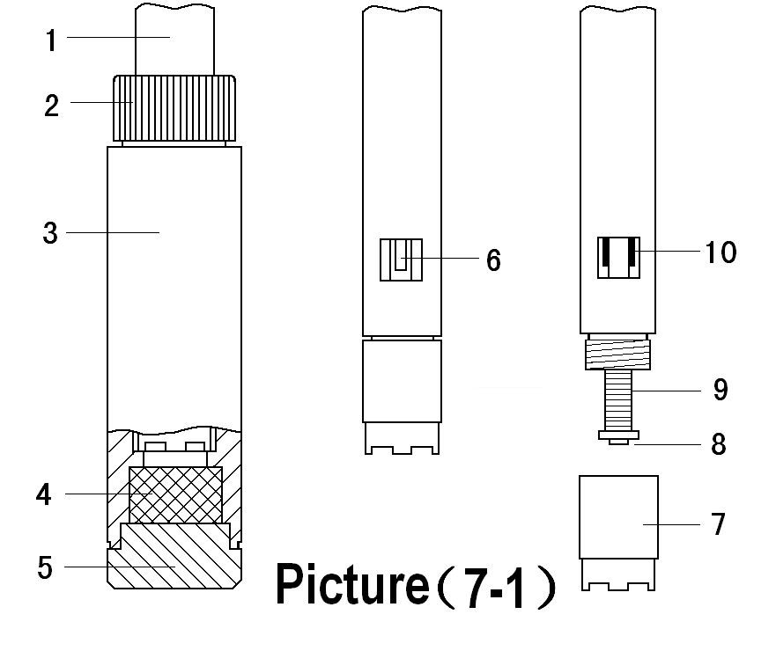

1— DO500 DO electrode
2 — Calibration cover cap
3 — Calibration cover
4 — Water stored sponge
5 — Calibration cover bottom lip
6 — Temperature electrode
7 — Membrane cap
8 — Cathode (gold slice)
9 — Anode
10 — Salinity electrode

7.2. Meter Calibration:
Press key, the meter enters into calibration mode, upper-right corner of LCD will display a flashing “CAL”. Access the DO electrode to calibration cover, and plug the cap of calibration cover tightly, place vertically to polarize 3 to 5 minutes, after the display values is stable and when appear the “ ” icon, again press key to calibrate. LCD will display flashing 100%, the calibration is finished after several seconds and return to the measuring mode. If the display value is unstable, please wait for several minutes and again press key until the calibrate value is completely stable.
7.3. Water Sample Test:
7.3.1. To measure in the flowing water (water sample velocity of flow >5cm/s): Insert the DO electrode into water, water surface should excess location of the thermistor which is on the electrode, the direction for electrode and water is 45°to 75°angle, and swing slightly the electrode, then hold 3 to 5 minutes to take the reading after stable displayed.
7.3.2. To measure in static water: Insert DO electrode into water, water surface should excess location of the thermistor, the direction for electrode and water is 45°to 75°angle, quickly remove the electrode in water, The remove speed is >5cm/s, hold 3 to 5 minutes to take the reading after stable displayed;
7.3.3. To test in the slower flowing water: according to the method of item 7.3.1.,but the remove speed of electrode should be faster.
7.4. Considerations:
7.4.1. The air temperature and water temperature should closer when test (≤10℃), if it is biggish different, please immerse the electrode into the sample water for about 10 minutes, then insert the electrode into the calibrate cover for 5 to 6 minutes according to item 7.2.1 and press the key to do calibration.
7.4.2. After each start-up meter must be carried out as required electrode polarization and calibration, so do not turn off the meter while using (when in the DO mode, the time for producer setting for auto power off is 0).
7.4.3. During DO test, temperature effects a lot on measuring value, because the thermistor of DO electrode is installed on the electrode housing, direct touches with water, not equips in the electrolyte of internal electrode, both of them have difference for sensibility on the water temperature, generally will need 3 to 5 minutes to make the thermistor temperature and the electrolyte within electrode of the actual temperature reached unanimity, so the reading time must be > 3 minutes, or else they would have a greater error, especially when the electrode temperature and water temperature has larger difference, will need to extend the reading time;
7.4.4. DO measurement also can be affected by Atmospheric pressure, and has biggish inaccuracy (please see Table V and Ⅵ). This meter has automatic Atmospheric pressure compensation function, and the measuring value has been amended by the Atmospheric pressure compensation,.
7.4.5. DO electrode can not be static test in the static water, otherwise it will lead the results to be lower.
7.4.6. When measuring, there can not have any bubbles for DO electrode and the sensitive membrane which touches with water, otherwise will affect measuring accuracy.
7.4.7. Electrode within the electrolyte can not have air bubbles (except for the smaller air bubbles), otherwise it will affect the response speed and accuracy. If a large air bubble, should screw out membrane cap, then add the electrolyte and membrane cap is screwed up;
7.4.8. Should keep the surface of DO electrode to be wet to prevent the cathode electrolyte withered, there is a piece of water stored sponge in calibration cover bottom, see picture (7-1), user must always maintain a moist sponge when the sponge is dried should be dropping some water on it (Let sponge saturated absorption, but you can not have a water flow). And tightly twist electrode cap, dissolved oxygen electrode should be kept in humid conditions.
7.4.9. The salinity electrode be installed in DO electrode (see picture (7-1)), the surface is plated with a layer of metal platinum black to reduce electrode polarization. The surface of platinum can not be rubbed. It only can be washed by shaking in water in case of damaging the platinum black coating. Wash the organic component pollution with tepid water containing detergent or with alcohol.
7.4.10. When it is abnormal for calibrating or displaying, please set the mode P7 to be “On” to restore meter to producer setting state, and then do calibrate and measure.
7.5. Parameter Setting:
7.5.1. DO parameter setting Table (Table (7-1))
Table (7-1)
Prompt Mark | Parameter Setting Items | Code | Parameter
P1 | Resolution selection |  | 0.01/0.1(mg/L and ppm) 0.1/1(%)
P2 | Salinity calibration
P3 | Atmospheric pressure setting
P4 | Temperature unit setting |  | ℃ ℉
P5 | Back light display time setting |  | 0-1-3-6 min
P6 | Auto power off time setting |  | 0-10-20 min
P7 | Restore to producer setting |  | OFF-On (shut-set)
7.5.2. Resolution selection (P1)
(a) Press key(>2s) and enter into P1 mode, see picture (7-2);
(b) Press key to choose resolution: 0.01→0.1;
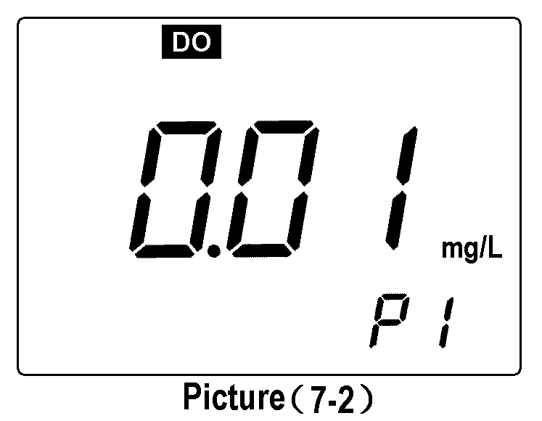
(c) Press key to enter into the next parameter setting or press return to the measuring interface.
7.5.3. Salinity calibration setting (P2)
(a) Under P1 mode, press key to enter into P2 mode, show as picture (7-3).
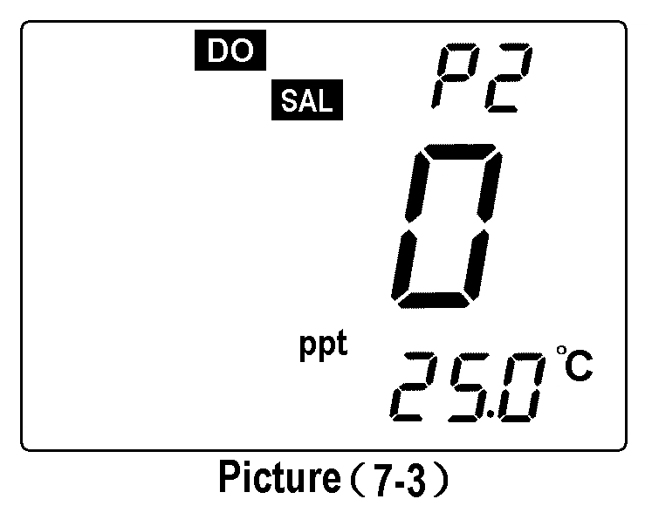
(b) Immerse the DO electrode into 12.88mS/cm calibration solution, solution level should excess salinity electrode, still it after stirring, then press the key when the value to be stable and appears an icon “ ”, the LCD displays a flickering “12.9”. The calibration is finished after several minutes and displays a stable salinity value.
(c) Press key to enter into the next parameter setting or press key to confirm and return to the measuring mode.
7.5.4. Atmospheric pressure setting (P3)
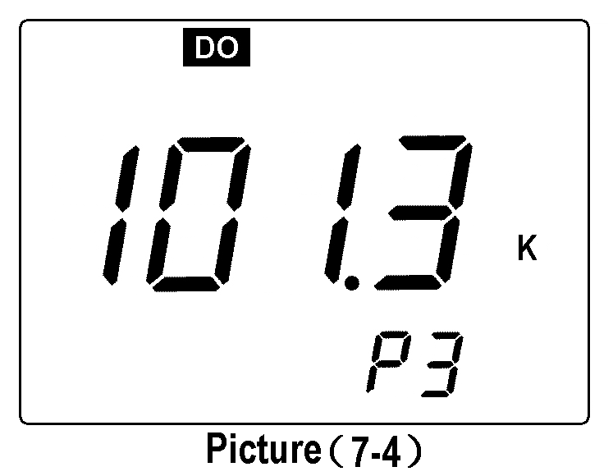
(a) Under mode P2, press key to enter into P3 mode, the LCD displays the Atmospheric pressure measuring value set earlier (unit is kPa), such as 101.3kPa, show as picture (7-4).
(b) Press or to change values according to standard Atmospheric pressure table, and longer press the or to quickly alter the value.
(c) Press key to enter into next parameter setting or press key to confirm and return to measuring mode.
7.5.5. Time unit℃/℉ selection (P4)
Under P3 mode to short press key and enter into P4 mode, the other operation, please refer to P14 item 4.4.5.
7.5.6. Time setting for back light display (P5)
Under P4 mode to short press key and enter into P5 mode, the other operation, please refer to P14 item 4.4.6.
7.5.7. Time setting for auto power off (P6)
Under P5 mode to short press key and enter into P6 mode, the other operation, please refer to P14 item 4.4.7.
Note: The producer setting for DO measurement mode is 0, that is, the function of auto power off is closed.
7.5.8. Restore to producer setting (P7)
Under P6 mode to short press key and enter into P7 mode, the other operation, please refer to P15 item 4.4.8.
7.6. Change the Membrane Cap:
When electrode response time to be longer, and displaying value appear obviously error, or when sensitive membrane of DO electrode has a wrinkle, crack or damaged, should replace a membrane cap according to the following steps.
(a) Loose the membrane cap and remove;
(b) Wash the electrode without membrane cap with purified water and throw off the water on it.
(c) Polish lightly on cathode surface (gold slice) with a piece of clear velvet or tissue;
(d) Inject electrolyte into a new membrane cap slowly and do not has any air bubbles appeared. After injected, should check the electrolyte to see whether there are air bubbles in it. If found there are air bubbles, please carefully knock on the membrane cap to dispel them.
(e) Put membrane cap on the table and set in the electrode vertically, slowly clockwise twist, then twist tightly. Temporality, redundant electrolyte will squeeze out, please wipe it out with tissue and clear it in the purified water.
(f) Check there is no air bubbles in electrolyte (beside the smaller air bubbles), otherwise, re-assembly is needed.
(g) No touching the sensitive membrane when use the electrode and replace the membrane cap for the sweat and grease will affect the quality of membrane and decrease the rate of oxygen permeability.
7.7. Zero Oxygen Calibration:
Generally need to do zero oxygen calibration in the situation of replacing electrode, replacing membrane cap, and long time without using. Usually no need to do zero oxygen calibration. To do zero oxygen calibration by the following steps:
(a) Preparing 100mL anaerobic water: In 100 mL beaker add 5g anhydrous sodium sulfite (Na₂SO3), plus 100 mL purified water stir to dissolve, anaerobic water is effective within 24 hours.
(b) To polarize electrode by connecting it into meter for 15min, and to do calibration according to the item 7.2.1;
(c) Put the electrode into anaerobic water, press key to make meter enter into calibration mode, when displaying value is ≤ 0.15mg/L (≤5min), again press
key to calibrate, then the LCD displays a flickering 0.0%, the calibration finishes after several seconds and the meter displays 0.00 mg/L, then wash the electrode with purified water;
(d) If the meter displayed value ≤0.02mg/L within 5 minutes, means the response speed of meter and residual current are good, need not to do zero oxygen calibration, press key to return to measuring mode.
(e) If the value of meter is displayed as >0.15 mg/L after 5 minutes, means the response speed of meter is slow and large residual current, at this time can change the membrane cap or remove the membrane cap and take out the polishing paper in the accessories to lightly wipe the catholic of gold plane (to the surface along the arc of gold-polished), and clean surface of cathode with soft cloth to tissue), and wash electrode with purified water and throw off the water on it. Add some electrolyte into the membrane cap, re-assembly and screw tightly, then to do full scale and zero oxygen calibration according to item 7.2. and 7.7.
7.8. Salinity Calibration:
The meter has salinity automatic compensation, but this salinity calibration is just need to apply in replacing a new electrode and long-time without using. In general do not need to do salinity calibration. The meter has already been made salinity calibration before leaving factory, so it is no need to do salinity calibration for fist time using. For the procedure of salinity calibration, please refer to P31 item 7.5.3.
7.9. Atmospheric pressure Setting:
The meter has the function of manual Atmospheric pressure compensation. It is suggested to reset the value according to the standard Atmospheric pressure table when there is a biggish change of Atmospheric pressure while using to ensure the accuracy of Atmospheric pressure compensation. For the procedure of Atmospheric pressure calibration, please see P32 item 7.5.4.

8. Meter’s Complete Kit:

8.1. Model SX751 pH/ORP/Conductivity/DO meter
1unit
1pc
1pc
1pc
1pc
1btl/each
1bottle
3pcs
1bottle
2pcs
1pcs
2pcs
1pcs
1pcs

8.2. 201T-S plastic pH/ATC three-in-one combination electrode
8.3. 301Pt-S plastic ORP combination electrode
8.4. 2301-S plastic conductivity electrode
8.5. DO500 DO electrode
8.6. pH standard buffer solution (pH4.00, pH7.00 and pH10.01/50mL)
8.7. 1413μS/cm conductivity standard solution (50mL)
8.8. DO503 membrane cap (DO electrode use)
8.9. DO502 DO electrode inner solution (30mL)
8.10. Cathode polishing paper
8.11. Screw driver
8.12. Spare AA batteries
8.13. Operation manual
8.14. Carrying case

9. Warranty:

9.1. We warrant this meter to be free of charge maintain, replace the parts or products under normal using circumstances, from purchased time within one year caused by manufacturing bad and unable to work.
9.2. Attached electrodes do not belong to this warrant range. But, if the newly purchased electrode went wrong without using, it’s free of charge to maintain and replace.
9.3. The above warranty is not apply to defects resulting from action of user such as misuse, improper wiring, operation outside of specification, improper maintenance or repair, or unauthorized modification.

Table І Meter Parameter Setting Table
Mode | Prompt Mark | Parameter Setting Items | Code | Parameter
pH | P1 | pH buffer solution series selection |  | USA(Europe & U.S.A. series)  NIS (NIST series)  CH (China series)
pH | P2 | Purified water pH temperature compensation setting |  | OFF-On (shut-set)
pH | P3 | Purified water added with ammonia pH temperature compensation setting |  | OFF-On (shut-set)
pH | P4 | Temperature unit seection |  | ℃ ℉
pH | P5 | Back light display time setting |  | 0-1-3-6min
pH | P6 | Auto power off time setting |  | 0-10-20min
pH | P7 | Restore to producer setting |  | OFF-On (shut-set)
mV | P1 | Back light display time setting |  | 0-1-3-6min
mV | P2 | Auto power off time setting |  | 0-10-20min
Cond. | P1 | Standard solution series selection |  | USA(84μS/cm, 1413μS/cm,  12.88 mS/cm, 111.9 mS/cm)  CH（146.6μS/cm, 1408μS/cm, 12.85mS/cm, 111.3 mS/cm）
Cond. | P2 | Electrode constant selection |  | 0.1, 1, 10
Cond. | P3 | Benchmark temperature selection |  | 25℃ 20℃ 18℃
Cond. | P4 | Temperature compensation coefficient setting |  | 0.00 to 9.99%
Cond. | P5 | Constant calibration setting
Cond. | P6 | Temperature unit setting |  | ℃ ℉
Cond. | P7 | Back light display time setting |  | 0-1-3-6min
Cond. | P8 | Auto power off time setting |  | 0-10-20min
Cond. | P9 | Restore to producer setting |  | OFF-On (shut-set)
DO | P1 | Resolution selection |  | 0.01/0.1(mg/L and ppm) 0.1, 1(%)
DO | P2 | Salinity calibration
DO | P3 | Atmospheric pressure setting |  | ℃ ℉
DO | P4 | Temperature unit selection |  | 0-1-3-6min
DO | P5 | Back light display time setting |  | 0-10-20min
DO | P6 | Auto power off time setting |  | OFF-On (shut-set)
DO | P7 | Restore to producer setting |  | OFF-On (shut-set)
TableⅡ Meter Restore to Producer Setting Table
Mode | Prompt Mark | Parameter Setting Items | Producer Setting Content | Non Producer Setting Content Icon
pH | P2 | Purified water pH temperature compensation setting | OFF
pH | P3 | Purified water added with ammonia pH temperature compensation setting | OFF
Cond. | P2 | Electrode constant type selection | K=1
Cond. | P3 | Benchmark temperature selection | 25℃
Cond. | P4 | Temperature compensation coefficient setting | 2.0%

TableⅢ Content of Saturated Oxygen in Water at Different Temperature

Temperature (℃) | DO(mg/L) | Temperature(℃) | DO(mg/L) | Temperature(℃) | DO(mg/L)
0 | 14.64 | 16 | 9.86 | 32 | 7.30
1 | 14.22 | 17 | 9.66 | 33 | 7.18
2 | 13.82 | 18 | 9.46 | 34 | 7.07
3 | 13.44 | 19 | 9.27 | 35 | 6.95
4 | 13.09 | 20 | 9.08 | 36 | 6.84
5 | 12.74 | 21 | 8.90 | 37 | 6.73
6 | 12.42 | 22 | 8.73 | 38 | 6.63
7 | 12.11 | 23 | 8.57 | 39 | 6.53
8 | 11.81 | 24 | 8.41 | 40 | 6.43
9 | 11.53 | 25 | 8.25 | 41 | 6.34
10 | 11.26 | 26 | 8.11 | 42 | 6.25
11 | 11.01 | 27 | 7.96 | 43 | 6.17
12 | 10.77 | 28 | 7.82 | 44 | 6.09
13 | 10.53 | 29 | 7.69 | 45 | 6.01
14 | 10.30 | 30 | 7.56
15 | 10.08 | 31 | 7.43
TableⅣ Content of Oxygen at Different Altitude
Altitude |  | Atmospheric pressure |  | DO | Altitude |  | Atmospheric pressure |  | DO
Foot | meter | kPa | mmHg | mg/l | Foot | meter | kPa | mmHg | mg/l
0 | 0 | 101.3 | 760 | 8.25 | 7500 | 2287 | 77.1 | 579 | 6.28
500 | 152 | 99.34 | 746 | 8.09 | 8000 | 2439 | 75.63 | 568 | 6.16
1000 | 305 | 97.6 | 733 | 7.95 | 8500 | 2591 | 74.44 | 559 | 6.06
1500 | 457 | 95.87 | 720 | 7.81 | 9000 | 2744 | 72.97 | 548 | 5.94
2000 | 610 | 94.28 | 708 | 7.68 | 9500 | 2896 | 71.64 | 538 | 5.83
2500 | 762 | 92.54 | 695 | 7.54 | 10000 | 3049 | 70.17 | 527 | 5.71
3000 | 915 | 90.95 | 683 | 7.41 | 10500 | 3201 | 68.84 | 517 | 5.61
3500 | 1067 | 89.35 | 671 | 7.28 | 11000 | 3354 | 67.38 | 506 | 5.49
4000 | 1220 | 87.75 | 659 | 7.15 | 12000 | 3659 | 66.58 | 500 | 5.42
4500 | 1372 | 86.15 | 647 | 7.02 | 13000 | 3963 | 65.78 | 494 | 5.36
5000 | 1524 | 84.56 | 635 | 6.89 | 14000 | 4268 | 64.98 | 488 | 5.29
5500 | 1677 | 83.09 | 624 | 6.77 | 15000 | 4573 | 64.18 | 482 | 5.23
6000 | 1829 | 81.63 | 613 | 6.65 | 16000 | 4878 | 63.38 | 476 | 5.16
6500 | 1982 | 80.03 | 601 | 6.52 | 17000 | 5183 | 62.58 | 470 | 5.10
7000 | 2134 | 78.56 | 590 | 6.40 | 18000 | 5488 | 61.79 | 464 | 5.03
TableⅤ Code Icon and Abbreviation Table
Explanation
English
Code and Abbreviation
Conductivity
Dissolved Oxygen
Resistivity
Total Dissolved Solid
Salinity
Standard solution
Solution
China series standard
China
Europe & U.S.A series standard
USA
NIST series standard
NIST
Temperature compensation coefficient setting
Temperature compensation coefficient setting
Coefficient
Electrode constant setting
Constant

End
Calibration
Benchmark temperature selection
Temperature Reference
Electrode constant setting
Constant Calibration
Purified water added with ammonia pH temperature compensation setting
Pure2
Purified water pH temperature compensation setting
Pure1

Table Ⅵ Content of Saturated Oxygen at Different Atmospheric Pressure
Atmospheric pressure |  | Dissovled Oxygen Concentration (mg/L)
mmHg | kPa | 15℃ | 25℃ | 35℃
750 | 100.00 | 9.94 | 8.14 | 6.85
751 | 100.13 | 9.96 | 8.15 | 6.86
752 | 100.26 | 9.97 | 8.16 | 6.87
753 | 100.40 | 9.98 | 8.17 | 6.88
754 | 100.53 | 9.99 | 8.18 | 6.89
755 | 100.66 | 10.00 | 8.20 | 6.90
756 | 100.80 | 10.01 | 8.21 | 6.91
757 | 100.93 | 10.03 | 8.22 | 6.92
758 | 101.06 | 10.04 | 8.23 | 6.93
759 | 101.20 | 10.07 | 8.24 | 6.94
760 | 101.33 | 10.08 | 8.25 | 6.95
761 | 101.46 | 10.09 | 8.26 | 6.96
762 | 101.60 | 10.11 | 8.27 | 6.97
763 | 101.73 | 10.12 | 8.28 | 6.98
764 | 101.86 | 10.14 | 8.30 | 6.99
765 | 102.00 | 10.15 | 8.31 | 7.00
766 | 102.13 | 10.16 | 8.32 | 7.01
767 | 102.26 | 10.18 | 8.33 | 7.02
768 | 102.40 | 10.19 | 8.34 | 7.02
769 | 102.53 | 10.21 | 8.35 | 7.03
770 | 102.66 | 10.22 | 8.36 | 7.04
771 | 102.80 | 10.23 | 8.37 | 7.05
772 | 102.93 | 10.25 | 8.39 | 7.06
773 | 103.06 | 10.26 | 8.40 | 7.07
774 | 103.19 | 10.28 | 8.41 | 7.08
775 | 103.33 | 10.29 | 8.42 | 7.09

Conversion between mmHg and kPa: mmHg×0.13333=kPa
DO_{pt} = P×DO_{t} ÷ 760
Note: DO_{pt} — DO concentration under temperature t, Atmospheric pressure P, mg/L;
P — Atmospheric pressure, mmHg;
DO_{t} — DO concentration under temperature t, Atmospheric pressure 760mmHg, mg/L;
760 — Atmospheric pressure, mmHg.

Shanghai San-Xin Instrumentation, Inc.

Add: 3/F. Building No.4, No. 471 Guiping Road, Shanghai, China. 200233
Tel: +86-21-63362480 Fax: +86-21-64956880
Website: www.shsan-xin.com E-mail: wxmab@shsan-xin.com

